WHEELCHAIR CONTROL THROUGH EYE BLINKING AND IOT PLATFORM

## A PROJECT REPORT

***Submitted by***

## JEYA GOKUL.CS [REGISTER NO:211417104098] ALAGU SRIRAM.S [REGISTER NO:211417104012] SARAVANAPANDI.P [REGISTER NO:211417104246]

***In partial fulfillment for the award of the degree Of***

**BACHELOR OF ENGINEERING**

## IN

**COMPUTER SCIENCE AND ENGINEERING**

## PANIMALAR ENGINEERING COLLEGE,CHENNAI-600123.

**ANNAUNIVERSITY: CHENNAI 600 025**

## APRIL 2020

i

**BONAFIDE CERTIFICATE**

Certified that this project report **“WHEELCHAIRTHROUGH EYE BLINKING AND IOT PLATFORM”** is the bonafide work of

## “ JEYA GOKUL.CS (2017PECCS407), ALAGU SRIRAM.S (2017PECCS358), SARAVANAPANDI.P (2017PECCS414) ” who

carried out the project work under my supervision.

**SIGNATURE SIGNATURE**

**Dr.S.MURUGAVALLI,M.E.,Ph.D., Mr.M.MOHAN,M.Tech.,(Ph.D.), HEAD OF THE DEPARTMENT ASSISTANT PROFESSOR(**GRADE-I), DEPARTMENT OF CSE, DEPARTMENT OF CSE,

PANIMALAR ENGINEERING COLLEGE, PANIMALAR ENGINEERING COLLEGE NAZARATHPETTAI, NAZARATHPETTAI,

POONAMALLEE, POONAMALLEE,

CHENNAI-600 123. CHENNAI-600 123.

.

Certified that the above candidate(s) was / were examined in the Anna University Project Viva-Voce Examination held on

**INTERNAL EXAMINER EXTERNAL EXAMINER**

**ACKNOWLEDGEMENT**

We wish our deep gratitude to our respected Secretary and Correspondent **Dr.P.CHINNADURAI, M.A., Ph.D.** for his kind words and enthusiastic motivation,which inspired us a lot in completing this project.

We would like to extend our heartfelt and sincere thanks to our Directors **Tmt.C.VIJAYARAJESWARI, Dr.C.SAKTHIKUMAR,M.E.,Ph.D.,** and **Tmt.SARANYASREE SAKTHIKUMAR B.E.,M.B.A.,** for

providing us with the necessary facilities for completion of this project.

We also express our gratitude to our Principal **Dr.K.Mani, M.E., Ph.D.,** for this timely concern and encouragement provided to us throughout the course.

We thank the HOD of CSE Department, **Dr.S.MURUGAVALLI**, **M.E.,Ph.D.** for the support extended throughout the project.

We would like to thank my Project Guide

**Mr.M.Krishnamurthy M.E,MBA,(Ph.D.)** and all the faculty members of the Department of CSE for their advice and suggestion for the successful completion of the project.

C.S JEYA GOKUL, S.ALAGU SRIRAM, P.SARAVANAPANDI.

iii

## ABSTRACT

Decision-making considering commands coming from eye blinking, to give mobility to a wheelchair, is not a simple task, bad decisions can end up in moving a person in a wrong direction, which will give more difficulties instead of solutions. In the actual study a microcontroller with embedded software and hardware for IoT is used, this device can manage multiple sensors as inputs and multiple actuators as outputs. The raspberry Pi 3 was selected because it is single-board computer with wireless LAN and Bluetooth Low Energy (BLE) on board. The developed system discriminates an involuntary blinking from a low motion voluntary blinking and take a decision to move forward a model wheelchair. The position and given commands are sent to an IoT platform to save the wheelchair movement data.

iv

## TABLE OF CONTENTS

**CHAPTER NO TITLE PAGE NO.**

|  |  |  |
| --- | --- | --- |
| **ABSTRACT**  **1. INTRODUCTION** | iv |  |
| 1.1 Existing System |  | 2 |
| 1.2 Proposed System |  | 2 |
| 1.3 Functional Block Diagram |  | 2 |
| 1.4 Hardware Requirements |  | 3 |
| 1.5 Software Requirements |  | 3 |
| 1. **MODULES ELUCIDATION**    1. Power Supply |  | 4 |
| 2.2 Raspberry Pi Microcontroller |  | 8 |
| 2.3 ADXL335 Accelerometer Module |  | 23 |
| 2.4 MCP3008 8-Channel 10-bit ADC IC |  | 26 |
| 2.5 Headphone |  | 33 |
| 2.6 L293D Motor Driver |  | 37 |
| 2.7 IR Sensor |  | 41 |
| 2.8 DC Motor or Direct Current Motor |  | 44 |
| **3. CIRCUIT DIAGRAM** |  | 49 |
| 1. **PROGRAMMING**    1. Introduction to Python |  | 50 |
| 4.2 Introduction to Firebase |  | 55 |
| 4.3 Firebase Services |  | 57 |
| 4.4 Firebase Cloud Messaging (FCM) |  | 61 |
| 4.5 Firebase App Indexing |  | 67 |

1. [LITERATURE SURVEY 80](#_TOC_250002)
2. [CONCLUSION 93](#_TOC_250001)
3. [REFERENCES 94](#_TOC_250000)

## CHAPTER 1: INTRODUCTION

The frequency of physical disability has increased in the past few decades and so has the use of technology. Taking this into consideration, this paper has been proposed which uses the trending technologies like IoT to provide patients with physical disability a means of mobility. A normal wheel chair has been used by modifying it to meet the objectives. This paper aims to design, integrate, program, interface and test monitories, head motion- controlled wheelchair by using gesture as an interface. Here, ADXL335 used to detect the motion of head and USB microphone is used to detect the voice commands. Using these two, we can operate the wheel chair by voice command as well head motions. Raspberry pi used to integrate the ADXL335 and Microphone with wheel Chair. It also equipped with emergency button used to intimate their helper or relative when they are in critical situation or they need help. When they press the emergency button, intimation send to their relative via mobile app. We also added proximity sensors in order to detect obstacles in their path. If obstacle detects in wheel chair path it will suggest the user to change the direction by means of voice.

* 1. **Existing System:**

EMERGENC Y BUTTON

RASPBERRY PI

In existing system, eye blink pattern is detected to control the movement of wheel chair. It is hard recognize the blink pattern in dynamic environment. It will only possible on static lighting and background environment.

* 1. **Proposed System:**

In proposed system, we are using dual mode control system for wheel chair. It can operate in voice recognition and head motion control model. It is also equipped with emergency button and obstacle detection features.

* 1. **Functional Block Diagram:**

POWER SUPPLY

ADXL335

LEFT IR

L293D MOTOR DRIVER

RIGHT IR

4 WHEEL ROBOT SETUP

SERVER

ANDROID APP

* 1. **Hardware Requirements:**
     + RASPBERRY PI 3 B+
     + ADXL335
     + IR SENSORS \*2
     + L293D MOTOR DRIVER MODULE
     + 4 WHEEL ROBOT SETUP
     + 12V BATTERY

## Software Requirements:

* + - Language : Python
    - Compiler : GCC Complier
    - OS : Linux

## CHAPTER 2: MODULES ELUCIDATION

* 1. **Power Supply:**

Alternating current (AC) is used for power line transmission and for high power devices like appliances and lights. The characteristics of AC make it ideal for transmission over long lines and for delivering large amounts of power for relatively unregulated uses, such as generating heat and light.

Lower power appliances and devices require the closely regulated control of direct current power (DC). As a normal house is supplied with AC, it must be converted to DC for many uses. Use these tips to learn how to make an AC DC converter.

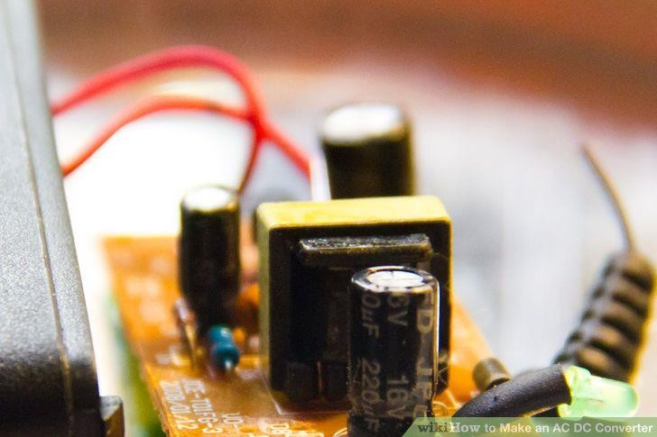

A transformer contains 2 magnetically coupled wire windings. One winding is called the primary. The primary is driven by the main AC supply. The other winding is called the secondary. The secondary serves as the power

input to the AC DC converter. This transformer and all of the other items needed to build the AC DC converter are readily available at electronic stores and hobby stores.

* + - Size the transformer windings. AC mains provide 120 volts AC. If 120 volts AC were directly converted to a DC voltage, the resulting DC voltage would be far too high a voltage for use by appliances and devices. The primary and secondary windings of the transformer are scaled to each other in order to produce a lower voltage on the secondary winding.
    - Choose a secondary winding. The AC output of the secondary winding should be rated as the same voltage of DC that is being created.



Wire the primary winding of the transformer to the main AC supply. This transformer connection has no polarity and may be connected either way.



Connect the secondary winding of the transformer to a full wave bridge rectifier package. The transformer connections and the connections to the marked inputs of the rectifier package have no polarity and may be connected either way.

* + - Build a full wave rectifier. This rectifier can be built up from 4 discrete rectifying diodes, rather than using a rectifier bridge package. The diodes will be marked to show a positive (cathode) end and a negative (anode) end. Connect the 4 diodes into a loop. Connect the cathode of diode 1 to the cathode of diode 2. Connect the anode of diode 2 to the cathode of diode 3. Connect the anode of diode 3 to the anode of diode 4. Connect the cathode of diode 4 to the anode of diode 1.
    - Wire the discrete rectifier to the transformer secondary. The transformer secondary should be connected to the cathode of diode 3 and the cathode of diode 4. There is no required polarity for these

connections. The positive output of the rectifier is at the point where the cathodes of diodes 1 and 2 join. The negative output of the rectifier is at the point where the anodes of diodes 3 and 4 join.

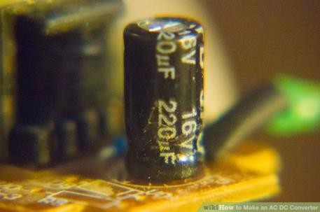

Attach a smoothing capacitor. Attach a polarized capacitor across the output connections of the rectifier. The positive terminal of the polarized capacitor must connect to the positive output of the regulator. This capacitor should be sized such that the capacitance in farads

1. is equal to (5 times the current to be supplied by the AC DC converter) divided by (transformer secondary rating times 1.4 times frequency). Frequency varies from country to country, but is typically either 50 Hertz (Hz) or 60 Hertz.

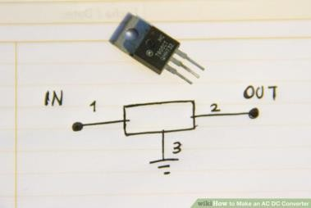

Provide the final regulation. Choose a commercially available voltage regulator designed to control the output of the AC DC converter to the desired

output voltage. The regulator will be a 3-pin device. The regulator pins will be a common, an input from the smoothing capacitor and an output of the regulator. This regulator output also will be the final output of the completed AC DC converter.

* + Wire the regulator as directed in the manufacturer's data sheet. There probably will be a noise suppression capacitor specified in the regulator manufacturer's data sheet. Acquire and install that capacitor per the manufacturer's data sheet for the regulator.

## Raspberry Pi Microcontroller:

**Raspberry Pi:**

The Raspberry Pi is a series of small [single-board computers](https://en.wikipedia.org/wiki/Single-board_computer) developed in the [United Kingdom](https://en.wikipedia.org/wiki/United_Kingdom) by the [Raspberry Pi Foundation](https://en.wikipedia.org/wiki/Raspberry_Pi_Foundation) to promote the teaching of basic [computer science](https://en.wikipedia.org/wiki/Computer_science) in schools and in [developing countries](https://en.wikipedia.org/wiki/Developing_countries).[[5](https://en.wikipedia.org/wiki/Raspberry_Pi#cite_note-5)[][6](https://en.wikipedia.org/wiki/Raspberry_Pi#cite_note-6)[][7]](https://en.wikipedia.org/wiki/Raspberry_Pi#cite_note-7) The original model became far more popular than anticipated,[[8]](https://en.wikipedia.org/wiki/Raspberry_Pi#cite_note-1000x-8) selling outside its [target market](https://en.wikipedia.org/wiki/Target_market) for uses such as [robotics](https://en.wikipedia.org/wiki/Robotics). It does not include peripherals (such as [keyboards](https://en.wikipedia.org/wiki/Keyboard_(computing)) and [mice](https://en.wikipedia.org/wiki/Mouse_(computing))) and [cases](https://en.wikipedia.org/wiki/Computer_case). However, some accessories have been included in several official and unofficial bundles.[[8]](https://en.wikipedia.org/wiki/Raspberry_Pi#cite_note-1000x-8)

The organisation behind the Raspberry Pi consists of two arms. The first two models were developed by the Raspberry Pi Foundation. After the Pi Model B was released, the Foundation set up Raspberry Pi Trading, with [Eben](https://en.wikipedia.org/wiki/Eben_Upton) [Upton](https://en.wikipedia.org/wiki/Eben_Upton) as CEO, to develop the third model, the B+. Raspberry Pi Trading is responsible for developing the technology while the Foundation is an educational charity to promote the teaching of basic computer science in schools and in developing countries.

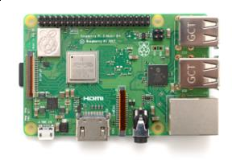According to the Raspberry Pi Foundation, more than 5 million Raspberry Pis were sold by February 2015, making it the best-selling [British computer](https://en.wikipedia.org/wiki/British_computer).[[9]](https://en.wikipedia.org/wiki/Raspberry_Pi#cite_note-9) By November 2016 they had sold 11 million units,[[10](https://en.wikipedia.org/wiki/Raspberry_Pi#cite_note-11_million-10)[][11]](https://en.wikipedia.org/wiki/Raspberry_Pi#cite_note-11) and 12.5m by March 2017, making it the third best-selling "general purpose computer".[[12]](https://en.wikipedia.org/wiki/Raspberry_Pi#cite_note-12) In July 2017, sales reached nearly 15 million.[[13]](https://en.wikipedia.org/wiki/Raspberry_Pi#cite_note-13) In March 2018, sales reached 19 million

## Generations of released model:

Several generations of Raspberry Pis have been released. All models feature a [Broadcom](https://en.wikipedia.org/wiki/Broadcom) [system on a chip](https://en.wikipedia.org/wiki/System_on_a_chip) (SoC) with an integrated [ARM](https://en.wikipedia.org/wiki/ARM_architecture)- compatible [central processing unit](https://en.wikipedia.org/wiki/Central_processing_unit) (CPU) and [on-chip graphics processing](https://en.wikipedia.org/wiki/Graphics_processing_unit#Integrated_graphics) [unit](https://en.wikipedia.org/wiki/Graphics_processing_unit#Integrated_graphics) (GPU).

Processor speed ranges from 700 MHz to 1.4 GHz for the Pi 3 Model B+; on- board memory ranges from 256 MB to 1 GB RAM. [Secure Digital](https://en.wikipedia.org/wiki/Secure_Digital) (SD) cards are used to store the operating system and program memory in either SDHC or MicroSDHC sizes. The boards have one to four USB ports. For video output, [HDMI](https://en.wikipedia.org/wiki/HDMI) and [composite video](https://en.wikipedia.org/wiki/Composite_video) are supported, with a standard 3.5 mm phono jack for audio output. Lower-level output is provided by a number of GPIO pins, which support common protocols like [I²C](https://en.wikipedia.org/wiki/I%C2%B2C). The B-models have an [8P8C](https://en.wikipedia.org/wiki/8P8C) [Ethernet](https://en.wikipedia.org/wiki/Ethernet) port and the Pi 3 and Pi Zero W have on-board Wi-Fi 802.11n and [Bluetooth](https://en.wikipedia.org/wiki/Bluetooth). Prices range from US$5 to $35.

The first generation (Raspberry Pi 1 Model B) was released in February 2012, followed by the simpler and cheaper Model A. In 2014, the Foundation released a board with an improved design, Raspberry Pi 1 Model B+. These boards are approximately credit-card sized and represent the standard *mainline* form-factor. Improved A+ and B+ models were released a

year later. A ["Compute Module"](https://en.wikipedia.org/wiki/Raspberry_Pi#Compute_module) was released in April 2014 for embedded applications. The Raspberry Pi 2, which added more RAM, was released in February 2015.

A Raspberry Pi Zero with smaller size and reduced [input/output](https://en.wikipedia.org/wiki/Input/output) (I/O) and [general-purpose input/output](https://en.wikipedia.org/wiki/General-purpose_input/output) (GPIO) capabilities was released in November 2015 for US$5. By 2017, it became the newest mainline Raspberry Pi. On 28 February 2017, the Raspberry Pi Zero W was launched, a version of the Zero with Wi-Fi and Bluetooth capabilities, for US$10.[[16](https://en.wikipedia.org/wiki/Raspberry_Pi#cite_note-16)[][17]](https://en.wikipedia.org/wiki/Raspberry_Pi#cite_note-17) On 12 January 2018, the Raspberry Pi Zero WH was launched, the same version of the Zero W with pre-soldered GPIO headers.[[18]](https://en.wikipedia.org/wiki/Raspberry_Pi#cite_note-18)

Raspberry Pi 3 Model B was released in February 2016 with a 64 bit [quad](https://en.wikipedia.org/wiki/Multi-core_processor) [core](https://en.wikipedia.org/wiki/Multi-core_processor) processor,on-board [WiFi](https://en.wikipedia.org/wiki/Wi-Fi), [Bluetooth](https://en.wikipedia.org/wiki/Bluetooth) and USB boot capabilities.[[19]](https://en.wikipedia.org/wiki/Raspberry_Pi#cite_note-19) On [Pi](https://en.wikipedia.org/wiki/Pi_Day) [Day](https://en.wikipedia.org/wiki/Pi_Day) 2018 model 3B+ appeared with a faster 1.4 GHz processor and a three times faster network based on [gigabit Ethernet](https://en.wikipedia.org/wiki/Gigabit_Ethernet) (300 Mbit / s) or 2.4 / 5 GHz dual-band [Wi-Fi](https://en.wikipedia.org/wiki/Wi-Fi) (100 Mbit / s).[[1]](https://en.wikipedia.org/wiki/Raspberry_Pi#cite_note-RapsberryPi3B%2BRelease-1) Other options are: [Power over](https://en.wikipedia.org/wiki/Power_over_Ethernet) [Ethernet](https://en.wikipedia.org/wiki/Power_over_Ethernet) (PoE), [USB boot](https://en.wikipedia.org/wiki/Universal_Serial_Bus) and [network boot](https://en.wikipedia.org/wiki/DHCP) (an [SD card](https://en.wikipedia.org/wiki/SD_card) is no longer required). This allows the use of the Pi in hard-to-reach places (possibly without electricity).

## Hardware:

The Raspberry Pi hardware has evolved through several versions that feature variations in memory capacity and peripheral-device support.

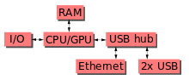

This block diagram describes Model B and B+; Model A, A+, and the Pi Zero are similar, but lack the [Ethernet](https://en.wikipedia.org/wiki/Ethernet) and [USB](https://en.wikipedia.org/wiki/USB) hub components. The Ethernet adapter is internally connected to an additional USB port. In Model A, A+, and the Pi Zero, the USB port is connected directly to the [system on a](https://en.wikipedia.org/wiki/System_on_a_chip) [chip](https://en.wikipedia.org/wiki/System_on_a_chip) (SoC). On the Pi 1 Model B+ and later models the USB/Ethernet chip contains a five-point USB hub, of which four ports are available, while the Pi 1 Model B only provides two. On the Pi Zero, the USB port is also connected directly to the SoC, but it uses a micro USB (OTG) port.

## Processor:

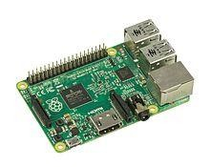

The Raspberry Pi 2B uses a 32-bit 900 MHz quad-core [ARM Cortex-](https://en.wikipedia.org/wiki/ARM_Cortex-A7) [A7](https://en.wikipedia.org/wiki/ARM_Cortex-A7)processor.

The [Broadcom](https://en.wikipedia.org/wiki/Broadcom) BCM2835 SoC used in the first generation Raspberry Pi[[20]](https://en.wikipedia.org/wiki/Raspberry_Pi#cite_note-Broadcom-BCM2835-Website-20) includes a 700 [MHz](https://en.wikipedia.org/wiki/Hertz) [ARM11](https://en.wikipedia.org/wiki/ARM11)76JZF-S processor, [VideoCore](https://en.wikipedia.org/wiki/VideoCore) IV [graphics processing unit](https://en.wikipedia.org/wiki/Graphics_processing_unit)(GPU),[[21]](https://en.wikipedia.org/wiki/Raspberry_Pi#cite_note-grandmax_brose_2012-21) and RAM. It has a level 1 (L1) [cache](https://en.wikipedia.org/wiki/CPU_cache) of 16 [KB](https://en.wikipedia.org/wiki/Kibibyte) and a level 2 (L2) cache of 128 KB. The level 2 cache is used primarily by the GPU. The SoC is [stacked](https://en.wikipedia.org/wiki/Package_on_package)underneath the RAM chip, so only its edge is visible. The 1176JZ(F)-S is the same CPU used in the [original iPhone](https://en.wikipedia.org/wiki/Original_iPhone),[[22]](https://en.wikipedia.org/wiki/Raspberry_Pi#cite_note-22) although at a higher clock rate, and mated with a much faster GPU.

The earlier V1.1 model of the Raspberry Pi 2 used a Broadcom BCM2836 SoC with a 900 MHz 32-bit quad-core [ARM Cortex-A7](https://en.wikipedia.org/wiki/ARM_Cortex-A7) processor, with 256 KB shared L2 cache.[[23]](https://en.wikipedia.org/wiki/Raspberry_Pi#cite_note-2-B-Announcement-23) The Raspberry Pi 2 V1.2 was upgraded to a Broadcom BCM2837 SoC with a 1.2 GHz 64-bit quad-core [ARM Cortex-](https://en.wikipedia.org/wiki/ARM_Cortex-A53) [A53](https://en.wikipedia.org/wiki/ARM_Cortex-A53) processor,[[24]](https://en.wikipedia.org/wiki/Raspberry_Pi#cite_note-24) the same SoC which is used on the Raspberry Pi 3, but underclocked (by default) to the same 900 MHz CPU clock speed as the V1.1. The BCM2836 SoC is no longer in production (as of late 2016).

The Raspberry Pi 3+ uses a Broadcom BCM2837B0 SoC with a 1.4 GHz 64- bit quad-core ARM Cortex-A53 processor, with 512 KB shared L2 cache.[[1]](https://en.wikipedia.org/wiki/Raspberry_Pi#cite_note-RapsberryPi3B%2BRelease-1)

## Performance:

While operating at 700 MHz by default, the first generation Raspberry Pi provided a real-world performance roughly equivalent to

0.041 [GFLOPS](https://en.wikipedia.org/wiki/FLOPS).[[25](https://en.wikipedia.org/wiki/Raspberry_Pi#cite_note-eLinux-perf-25)[][26]](https://en.wikipedia.org/wiki/Raspberry_Pi#cite_note-hackaday-raspi-26) On the [CPU](https://en.wikipedia.org/wiki/Central_processing_unit) level the performance is similar to a 300 MHz [Pentium II](https://en.wikipedia.org/wiki/Pentium_II) of 1997–99. The GPU provides 1 [Gpixel](https://en.wikipedia.org/wiki/Gpixel)/s or

1.5 [Gtexel](https://en.wikipedia.org/wiki/Texel_(graphics))/s of graphics processing or 24 GFLOPS of general purpose computing performance. The graphical capabilities of the Raspberry Pi are roughly equivalent to the performance of the [Xbox](https://en.wikipedia.org/wiki/Xbox_(console)) of 2001.

Raspberry Pi 2 V1.1 included a quad-core Cortex-A7 CPU running at 900 MHz and 1 GB RAM. It was described as 4–6 times more powerful than its predecessor. The GPU was identical to the original.[[23]](https://en.wikipedia.org/wiki/Raspberry_Pi#cite_note-2-B-Announcement-23) In parallelised benchmarks, the Raspberry Pi 2 V1.1 could be up to 14 times faster than a Raspberry Pi 1 Model B+.[[27]](https://en.wikipedia.org/wiki/Raspberry_Pi#cite_note-27)

The Raspberry Pi 3, with a quad-core [ARM Cortex-A53](https://en.wikipedia.org/wiki/ARM_Cortex-A53) processor, is described as having ten times the performance of a Raspberry Pi 1.[[28]](https://en.wikipedia.org/wiki/Raspberry_Pi#cite_note-%3A0-28) This was suggested to be highly dependent upon task [threading](https://en.wikipedia.org/wiki/Thread_(computing)) and [instruction](https://en.wikipedia.org/wiki/Instruction_set) [set](https://en.wikipedia.org/wiki/Instruction_set) use. Benchmarks showed the Raspberry Pi 3 to be approximately 80% faster than the Raspberry Pi 2 in parallelised tasks.[[29]](https://en.wikipedia.org/wiki/Raspberry_Pi#cite_note-29)

## Overclocking:

Most Raspberry Pi chips could be [overclocked](https://en.wikipedia.org/wiki/Overclocking) to 800 MHz, and some to 1000 MHz. There are reports the Raspberry Pi 2 can be similarly overclocked, in extreme cases, even to 1500 MHz (discarding all safety features and over- voltage limitations). In the [Raspbian](https://en.wikipedia.org/wiki/Raspberry_Pi#Software) [Linux distro](https://en.wikipedia.org/wiki/Linux_distro) the overclocking options on [boot](https://en.wikipedia.org/wiki/Booting) can be done by a software command running "sudo raspi-config" without voiding the warranty.[[30]](https://en.wikipedia.org/wiki/Raspberry_Pi#cite_note-Turbo_mode-30) In those cases the Pi automatically shuts the overclocking down if the chip temperature reaches 85 °C (185 °F), but it is possible to override automatic over-voltage and overclocking settings (voiding the warranty); an appropriately sized [heat sink](https://en.wikipedia.org/wiki/Heat_sink) is needed to protect the chip from serious overheating.

Newer versions of the firmware contain the option to choose between five overclock ("turbo") presets that when used, attempt to maximise the performance of the SoC without impairing the lifetime of the board. This is done by monitoring the core temperature of the chip and the CPU load, and dynamically adjusting clock speeds and the core voltage. When the demand is low on the CPU or it is running too hot the performance is throttled, but if the CPU has much to do and the chip's temperature is acceptable, performance is temporarily increased with clock speeds of up to 1 GHz, depending on the individual board and on which of the turbo settings is used.

## The seven overclock presets are:

* none; 700 MHz ARM, 250 MHz core, 400 MHz SDRAM, 0 [overvolting](https://en.wikipedia.org/wiki/Overvolting)
* modest; 800 MHz ARM, 250 MHz core, 400 MHz SDRAM, 0 overvolting,
* medium; 900 MHz ARM, 250 MHz core, 450 MHz SDRAM, 2 overvolting,
* high; 950 MHz ARM, 250 MHz core, 450 MHz SDRAM, 6 overvolting,
* turbo; 1000 MHz ARM, 500 MHz core, 600 MHz SDRAM, 6 overvolting,
* Pi 2; 1000 MHz ARM, 500 MHz core, 500 MHz SDRAM, 2 overvolting,
* Pi 3; 1100 MHz ARM, 550 MHz core, 500 MHz SDRAM, 6 overvolting.

In system information the CPU speed will appear as 1200 MHz. When idling, speed lowers to 600 MHz.[[30](https://en.wikipedia.org/wiki/Raspberry_Pi" \l "cite_note-Turbo_mode-30)[][31]](https://en.wikipedia.org/wiki/Raspberry_Pi#cite_note-turbosgithub-31)

In the highest (*turbo*) preset the SDRAM clock was originally 500 MHz, but this was later changed to 600 MHz because 500 MHz sometimes causes SD card corruption. Simultaneously in *high* mode the core clock speed was lowered from 450 to 250 MHz, and in *medium* mode from 333 to 250 MHz.The Raspberry Pi Zero runs at 1 GHz.The CPU on the first and second generation Raspberry Pi board did not require cooling, such as a heat

sink or [fan](https://en.wikipedia.org/wiki/Computer_fan), even when overclocked, but the Raspberry Pi 3 may generate more heat when overclocked.[[32]](https://en.wikipedia.org/wiki/Raspberry_Pi#cite_note-32)

## RAM:

On the older beta Model B boards, 128 MB was allocated by default to the GPU, leaving 128 MB for the CPU.[[33]](https://en.wikipedia.org/wiki/Raspberry_Pi#cite_note-33) On the first 256 MB release Model B (and Model A), three different splits were possible. The default split was 192 MB (RAM for CPU), which should be sufficient for standalone 1080p video decoding, or for simple 3D, but probably not for both together. 224 MB was for Linux only, with only a 1080p [framebuffer](https://en.wikipedia.org/wiki/Framebuffer), and was likely to fail for any video or 3D. 128 MB was for heavy 3D, possibly also with video decoding (e.g. XBMC).[[34]](https://en.wikipedia.org/wiki/Raspberry_Pi#cite_note-34) Comparatively the [Nokia 701](https://en.wikipedia.org/wiki/Nokia_701) uses 128 MB for the Broadcom VideoCore IV.[[35]](https://en.wikipedia.org/wiki/Raspberry_Pi#cite_note-35)

For the later Model B with 512 MB RAM new standard memory split files (arm256\_start.elf, arm384\_start.elf, arm496\_start.elf) were initially released for 256 MB, 384 MB and 496 MB CPU RAM (and 256 MB, 128 MB and

16 MB video RAM) respectively. But a week or so later the RPF released a new version of start.elf that could read a new entry in config.txt (gpu\_mem=*xx*) and could dynamically assign an amount of RAM (from 16 to 256 MB in 8 MB steps) to the GPU, so the older method of memory splits

became obsolete, and a single start.elf worked the same for 256 MB and 512 MB Raspberry Pis.[[36]](https://en.wikipedia.org/wiki/Raspberry_Pi#cite_note-36)

The Raspberry Pi 2 and the Raspberry Pi 3 have 1 GB of RAM.[[37](https://en.wikipedia.org/wiki/Raspberry_Pi#cite_note-37)[][38]](https://en.wikipedia.org/wiki/Raspberry_Pi#cite_note-38) The Raspberry Pi Zero and Zero W have 512 MB of RAM.

## Networking:

The Model A, A+ and Pi Zero have no Ethernet circuitry and are commonly connected to a network using an external user-supplied USB Ethernet or [Wi-](https://en.wikipedia.org/wiki/Wi-Fi) [Fi](https://en.wikipedia.org/wiki/Wi-Fi) adapter. On the Model B and B+ the Ethernet port is provided by a built-in USB Ethernet adapter using the SMSC LAN9514 chip.[[39]](https://en.wikipedia.org/wiki/Raspberry_Pi#cite_note-SMSC-LAN9514-specs-39) The Raspberry Pi 3 and Pi Zero W (wireless) are equipped with 2.4 GHz WiFi [802.11n](https://en.wikipedia.org/wiki/IEEE_802.11n-2009) (150 Mbit/s) and [Bluetooth 4.1](https://en.wikipedia.org/wiki/Bluetooth_4.1) (24 Mbit/s) based on the Broadcom BCM43438 [FullMAC](https://en.wikipedia.org/wiki/Wireless_network_interface_controller#FULLMAC) chip with no official support for [monitor mode](https://en.wikipedia.org/wiki/Monitor_mode) but implemented through unofficial firmware patching[[40]](https://en.wikipedia.org/wiki/Raspberry_Pi#cite_note-40) and the Pi 3 also has a 10/100 Mbit/s Ethernet port. The Raspberry Pi 3B+ features dual-band [IEEE](https://en.wikipedia.org/wiki/IEEE_802.11) [802.11b/g/n/ac WiFi](https://en.wikipedia.org/wiki/IEEE_802.11), [Bluetooth 4.2](https://en.wikipedia.org/wiki/Bluetooth_4.2), and [Gigabit Ethernet](https://en.wikipedia.org/wiki/1000BASE-T) (limited to approximately 300 Mbit/s by the [USB 2.0](https://en.wikipedia.org/wiki/USB_2.0) bus between it and the SoC).

## Peripherals:

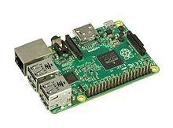

The Model 2B boards incorporate four USB ports for connecting peripherals.

The Raspberry Pi may be operated with any generic [USB computer](https://en.wikipedia.org/wiki/USB_computer_keyboard) [keyboard](https://en.wikipedia.org/wiki/USB_computer_keyboard) and [mouse](https://en.wikipedia.org/wiki/Mouse_(computing)).[[41]](https://en.wikipedia.org/wiki/Raspberry_Pi#cite_note-VerifiedPeripheralList-41) It may also be used with USB storage, USB to MIDI converters, and *virtually* any other device/component with USB capabilities.

Other peripherals can be attached through the various pins and connectors on the surface of the Raspberry Pi.[[42]](https://en.wikipedia.org/wiki/Raspberry_Pi#cite_note-42)

## Video:

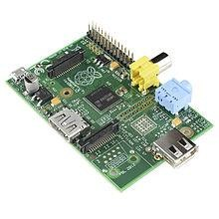

The early Raspberry Pi 1 Model A, with an HDMI port and a standard RCA composite video port for older displays

The video controller can generate standard modern TV resolutions, such as HD and [Full HD](https://en.wikipedia.org/wiki/Full_HD), and higher or lower monitor resolutions as well as older NTSC or PAL standard CRT TV resolutions. As shipped (i.e., without custom overclocking) it can support the following resolutions: 640×350 [EGA](https://en.wikipedia.org/wiki/Enhanced_Graphics_Adapter); 640×480 [VGA](https://en.wikipedia.org/wiki/Video_Graphics_Array); 800×600 [SVGA](https://en.wikipedia.org/wiki/Super_video_graphics_array); 1024×768 [XGA](https://en.wikipedia.org/wiki/XGA); 1280×720 [720p](https://en.wikipedia.org/wiki/720p) [HDTV](https://en.wikipedia.org/wiki/High-definition_television#High-definition_display_resolutions);

1280×768 [WXGA](https://en.wikipedia.org/wiki/Graphic_display_resolutions#WXGA) variant; 1280×800 [WXGA](https://en.wikipedia.org/wiki/Graphic_display_resolutions#WXGA)variant; 1280×1024 [SXGA](https://en.wikipedia.org/wiki/SXGA);

1366×768 [WXGA](https://en.wikipedia.org/wiki/Graphic_display_resolutions#WXGA) variant; 1400×1050 [SXGA+](https://en.wikipedia.org/wiki/SXGA%2B); 1600×1200 [UXGA](https://en.wikipedia.org/wiki/UXGA);

1680×1050 [WXGA+](https://en.wikipedia.org/wiki/WXGA%2B); 1920×1080 [1080p](https://en.wikipedia.org/wiki/1080p) [HDTV](https://en.wikipedia.org/wiki/High-definition_television#High-definition_display_resolutions); 1920×1200 [WUXGA](https://en.wikipedia.org/wiki/WUXGA).[[43]](https://en.wikipedia.org/wiki/Raspberry_Pi#cite_note-video-43)

Higher resolutions, up to 2048×1152, may work[[44](https://en.wikipedia.org/wiki/Raspberry_Pi#cite_note-44)[][45]](https://en.wikipedia.org/wiki/Raspberry_Pi#cite_note-45) or even 3840×2160 at 15 Hz (too low a frame rate for convincing video).[[46]](https://en.wikipedia.org/wiki/Raspberry_Pi#cite_note-46) Note also that allowing the highest resolutions does not imply that the GPU can decode video formats at these resolutions; in fact, the Pis are known to not work reliably for [H.265](https://en.wikipedia.org/wiki/H.265) (at those high resolutions), commonly used for very high resolutions (however, most common formats up to Full HD do work).

Although the Raspberry Pi 3 does not have H.265 decoding hardware, the CPU is more powerful than its predecessors, potentially fast enough to allow the decoding of H.265-encoded videos in software.[[47]](https://en.wikipedia.org/wiki/Raspberry_Pi#cite_note-47) The GPU in the Raspberry Pi 3 runs at higher clock frequencies of 300 MHz or 400 MHz, compared to previous versions which ran at 250 MHz.[[48]](https://en.wikipedia.org/wiki/Raspberry_Pi" \l "cite_note-48)

The Raspberry Pis can also generate [576i](https://en.wikipedia.org/wiki/576i) and [480i](https://en.wikipedia.org/wiki/480i) [composite video](https://en.wikipedia.org/wiki/Composite_video) signals, as used on old-style ([CRT](https://en.wikipedia.org/wiki/Cathode_ray_tube)) TV screens and less-expensive monitors through standard connectors – either RCA or 3.5 mm phono connector depending on models. The television signal standards supported are [PAL-BGHID](https://en.wikipedia.org/wiki/PAL%23PAL-B/G/D/K/I), [PAL-](https://en.wikipedia.org/wiki/PAL-M) [M](https://en.wikipedia.org/wiki/PAL-M), [PAL-N](https://en.wikipedia.org/wiki/PAL-N), [NTSC](https://en.wikipedia.org/wiki/NTSC) and [NTSC-J](https://en.wikipedia.org/wiki/NTSC-J).[[49]](https://en.wikipedia.org/wiki/Raspberry_Pi#cite_note-composite-49)

## Real-time clock:

None of the current Raspberry Pi models have a built-in [real-time clock](https://en.wikipedia.org/wiki/Real-time_clock), so they are unable to keep track of the time of day independently. As a workaround, a program running on the Pi can retrieve the time from a [network](https://en.wikipedia.org/wiki/Network_Time_Protocol) [time server](https://en.wikipedia.org/wiki/Network_Time_Protocol) or from user input at boot time, thus knowing the time while powered on. To provide consistency of time for the [file system](https://en.wikipedia.org/wiki/File_system), the Pi automatically saves the current system time on shutdown, and re-loads that time at boot.

A real-time hardware clock with battery backup, such as the DS1307, may be added (often via the [I²C](https://en.wikipedia.org/wiki/I%C2%B2C) interface).

## Operating systems:

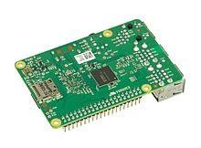

Various operating systems for the Raspberry Pi can be installed on a MicroSD, MiniSD or SD card, depending on the board and available adapters; seen here is the MicroSD slot located on the bottom of a Raspberry Pi 2 board.

The Raspberry Pi Foundation provides [Raspbian](https://en.wikipedia.org/wiki/Raspbian), a Debian-based [Linux](https://en.wikipedia.org/wiki/Linux_distribution) [distribution](https://en.wikipedia.org/wiki/Linux_distribution)for download, as well as third-party [Ubuntu](https://en.wikipedia.org/wiki/Ubuntu_(operating_system)), [Windows 10 IoT](https://en.wikipedia.org/wiki/Windows_10_IoT_Core) [Core](https://en.wikipedia.org/wiki/Windows_10_IoT_Core), [RISC OS](https://en.wikipedia.org/wiki/RISC_OS), and specialised [media centre](https://en.wikipedia.org/wiki/OpenELEC) distributions.[[106]](https://en.wikipedia.org/wiki/Raspberry_Pi#cite_note-raspberrypi_downloads-106) It promotes [Python](https://en.wikipedia.org/wiki/Python_(programming_language)) and [Scratch](https://en.wikipedia.org/wiki/Scratch_(programming_language)) as the main programming languages, with support for many other languages.[[107]](https://en.wikipedia.org/wiki/Raspberry_Pi#cite_note-107) The default [firmware](https://en.wikipedia.org/wiki/Firmware) is [closed source](https://en.wikipedia.org/wiki/Closed_source), while an unofficial [open source](https://en.wikipedia.org/wiki/Open_source) is available.[[108](https://en.wikipedia.org/wiki/Raspberry_Pi#cite_note-108)[][109](https://en.wikipedia.org/wiki/Raspberry_Pi#cite_note-109)[][110]](https://en.wikipedia.org/wiki/Raspberry_Pi#cite_note-110) Many other operating systems can also run on the Raspberry Pi. Other third-party operating systems available via the official website include [Ubuntu MATE](https://en.wikipedia.org/wiki/Ubuntu_MATE), [Windows 10 IoT](https://en.wikipedia.org/wiki/Windows_10_IoT_Core) [Core](https://en.wikipedia.org/wiki/Windows_10_IoT_Core), [RISC OS](https://en.wikipedia.org/wiki/RISC_OS) and specialised distributions for the [Kodi](https://en.wikipedia.org/wiki/Kodi_(software)) media centre and classroom management.

## ADXL335 Accelerometer Module:

The **ADXL335** is a small, low power, complete 3-axis accelerometer with signal conditioned voltage outputs. It can measure the static acceleration of gravity in tilt-sensing applications, as well as dynamic acceleration resulting from motion, shock, or vibration

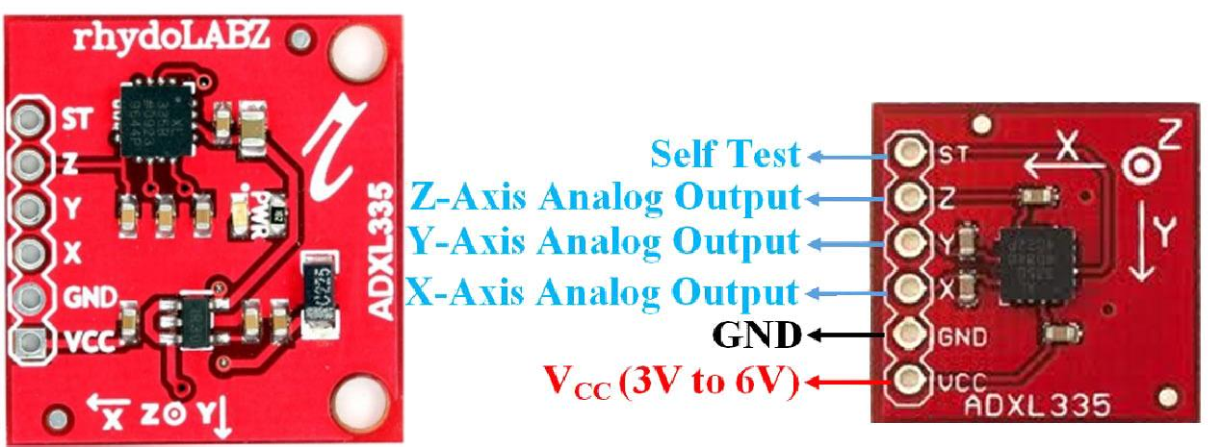

Accelerometer Module Features & Specifications

* + - Operating Voltage: 3V to 6V DC
    - Operating Current: 350μA
    - Sensing Range: ±3g
    - 3-axis sensing
    - High Sensitivity for small movements
    - Needs no external components
    - Easy to use with Microcontrollers or even with normal Digital/Analog IC
    - Small, cheap and easily available

## ADXL335 Pinout Configuration:

|  |  |
| --- | --- |
| **Pin Name** | **Description** |
| VCC | The Vcc pin powers the module, typically with +5V |
| GND | Power Supply Ground |
| X | X-axis Analog Output Pin |
| Y | Y-axis Analog Output Pin |
| Z | Z-axis Analog Output Pin |
| ST | Self-Test Pin. This pin controls the Self-Test feature. |

**Brief about Accelerometer Module:**

This **ADXL335 Accelerometer module** consists of an ADXL335 Accelerometer IC, Voltage Regulator IC, resistors, and capacitors in an integrated circuit. Different manufacturers use a different voltage regulator IC. Most of the modules use XC6206P332MR (662K) IC.

ADXL335 IC from Analog Devices is the brain of this module. The ADXL335 is a small, thin, low power, complete 3-axis accelerometer with signal conditioned voltage outputs. The product measures acceleration with a minimum full-scale range of ±3 g.

Apart from ADXL335 IC this module also consists of a 3.3V voltage regulator IC.

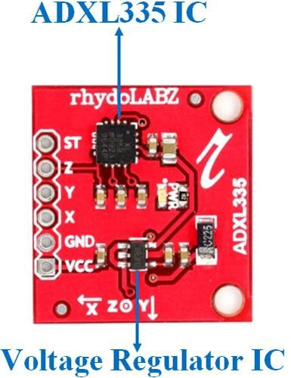

## How to Use the ADXL335 Accelerometer Module:

ADXL335 Accelerometer module consists of six pins i.e. VCC, GND, X, Y, Z, and ST. Using the Accelerometer module with a microcontroller is very

easy. Connect VCC and GND pins to 5V and GND pins of Microcontroller. Also connect X, Y, and Z pins to the Analog pins of Arduino. The basic structure of the accelerometer consists of fixed plates and moving plates. When the acceleration is applied on an axis capacitance between fixed plates and moving plates is changed. This results in a sensor output voltage amplitude which is proportional to the acceleration.

## Applications of ADXL335 Accelerometer:

* + - Cost-sensitive, low power, motion- and tilt-sensing applications
    - Mobile devices
    - Gaming systems
    - Disk drive protection
    - Image stabilization
    - Sports and health devices

## MCP3008 8-Channel 10-bit ADC IC:

The **MCP3008** is an **8-Channel 10-bit ADC IC**, so it can measure 8 different analog voltage with a resolution of 10-bit. It measures the value of analog voltage from 0-1023 and sends the value to a microcontroller or

microprocessor through **SPI communication**. It can operate on both 3.3V and 5V and hence it can be used with 5V microcontroller as well as with 3.3V systems like the [Raspberry Pi](https://components101.com/microcontrollers/raspberry-pi-3-pinout-features-datasheet). It uses the SAR method to convert the Analog voltage to digital value; it might not be the fastest and precise ADC in the market but is the cheapest and easy to use one.

So if you are looking for an **ADC IC** with a resolution of 10-bit (0-1023) with 8-channels with a decent speed then this IC might be the right choice for you. It is very commonly used with Raspberry Pi since it does not have an ADC feature by default.

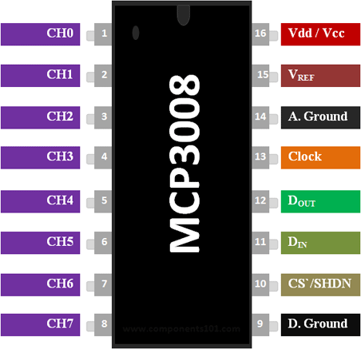

|  |  |  |
| --- | --- | --- |
| **Pin N)** | **Pin Name** | **Description** |
| 1,2,3,4,5,  6,7,8 | Analog Input Channels | These are the 8 Input pins, to which the analog voltage which has to be measured is provided. |
| 9 | Digital Ground | Connected to the Ground of the circuit |

|  |  |  |
| --- | --- | --- |
| 10 | Chip Select / Shutdown(CS`/SHD N) | This pin is connected to GPIO pin or MCU for turning on or off the IC |
| 11 | Serial Data In (DIN) | Used for SPI communication |
| 12 | Serial Data Out (DOUT) | Used for SPI communication |
| 13 | Serial Clock (CLK) | Used to provide clock signal for SPI communication |
| 14 | Analog Ground | Connected to Ground of the reference voltage |
| 15 | Reference Voltage (VREF) | Connected to reference voltage for ADC Conversion |

## Features:

* + - 8-Channel 10-bit ADC IC
    - Communication protocol: Serial SPI interface
    - Operating voltage 2.7V to 5V
    - ADC method: Successive Approximation (SAR)
    - Sampling Rate: 200ksps and 75ksps for 5V and 2.7V resp.
    - Available in 16-pin PDIP, and SOIC packages

**How to use a MCP3008 IC:**

**MCP3008** is popular because of its user friendly nature and can be made to work with minimum number of components. A **sample application circuit for MCP3008** is shown below.

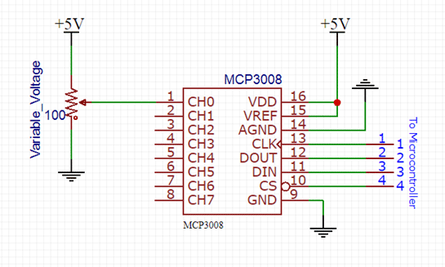

In this sample diagram I have set the operating voltage to be 5V, but it can be anywhere between 2.7V to 5V. The ADC works using the SAR method, so it requires a reference voltage to calculate the unknown voltage. This reference voltage should always be less than the operating voltage; normally it will be as same as the operating voltage. In our case I have tied the reference voltage to 5V along with Vcc pin.

The channel pin CH0 to CH7 can be used to feed in the analog voltage which has to be measured. The maximum voltage that can be measured with each is pin will be equal to the reference voltage. In our case it is 5V. Each pin measures the voltage with a resolution on 10-bit meaning the input voltage of

* 1. V is converted to 0-1023 digital data. The formulae to convert this digital data back into voltage is:

ADC to Voltage Formula

In the above circuit diagram the system voltage is 5V and the resolution of ADC is 1024. Once the Analog voltage is measured by the IC, its value can be obtained by the microcontroller or microprocessor through SPI communication. To do this the CS, Din, Dout and Clock pin of the IC is connected to the microcontroller or microprocessors SPI pins. Then using SPI communication protocol we have to send the control bit data for selecting the channel number from which the ADC value has to be obtained and the IC will reply us back with the value. More details on how to do this can be found at page 19 in the datasheet given below.

If you are interfacing this IC with [Arduino](https://components101.com/microcontrollers/arduino-uno) or Raspberry Pi then you do not have to worry about it a lot because Adafruit has provided a Adafruit MCP3008 Python Library which can be downloaded from the link given and used directly to work with all versions of Raspberry Pi.

## Applications:

* + - Used with Raspberry Pi and other microprocessor development boards
    - Extended ADC modules
    - Data acquisition where multiple analog sensors are present
    - Multiple sensor interface projects
    - Battery pack monitoring

## Headphone:

Speakers are transducers that convert electromagnetic waves into sound waves. The speakers receive audio input from a device such as a computer or an audio receiver. This input may be either in analog or digital form. Analog speakers simply amplify the analog electromagnetic waves into sound waves.

## Working Principle of a Speaker:

Translation of electrical signal into a pure sound is made possible by speakers. A plastic, paper, fabric or lightweight metal cone exist at the front of a speaker. To the outer of the circular rim of the speaker is firmly attached the outer part of the cone.

The inner part of the speaker is firmly fixed to an iron coil (Voice coil) which is in front of a permanent magnet. The iron coil is referred to as electromagnet

i.e. a metal in which when electric current flows through which creates a magnetic field.



This iron coil is more or less like a permanent magnet. This electromagnet is always mobile but the permanent magnet is always firmly fixed into position. The electrical signal enters through the speaker cables into the coil when the speaker is hooked up to a stereo.

As the electric pulses pass through the electromagnetic coil back and forth, the electromagnet also attracts and repels the permanent magnet respectively. These results into moving the coil forward and backward and the speaker cone also experience push and pull in the like manner. The pull and push of the speaker cone sends out into the air an audible sound.

When the speaker cone vibrates very fast or hard, the speaker plays loud and plays soft when the cone moves slowly. Thus, louder sound is generated when the cone receives greater electricity pulse and sending of small electric pulse into the cone of a speaker results into soft sound.

Low frequencies are better produced by big speakers that possesses large cone (also known as woofers) because they move slowly while small speaker with small cone are poor producers of low frequency sound.

## Making a Better Sound Out of a Speaker:

Movement of cone is not the main determinant of how the speaker sounds. The plastic or wooden cases in which they are built in also makes them to sound better. This is a replica of what happens in guitar. When the string of a guitar vibrates, the air in the wooden body of the guitar also vibrates thereby, amplifies the sound of the strings and makes it loud adequately for hearing. Without the production of resonance between the speakers and the cases, the hearing of the sound will be hardly pronounced.

Sound waves are discharged out of speakers in all direction but speaker cone sound waves could only be heard when it travels through the air in the room. The sound waves produced by the speaker are bounced off the wall, furniture

and floors of a room and in many ways interact. An empty room will always sound differently from a furniture filled room when the same set of speakers are involved. A kitchen or a bathroom filled with lots of hard materials will sound different from a living room filled with soft furniture and rugs.

## Electrostatic Speaker:

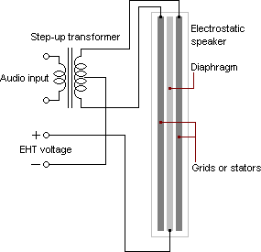

There are few other technologies of speakers which do not make use of electromagnet to push and pull of the cone- shaped diaphragm. These speakers are referred to as electrostatic speakers. These speakers possess a thin conductive diaphragm panel and a stationary conductive panel. Electrostatic speakers make use of a thin conductive diaphragm panel to vibrate air.

The thin conductive diaphragm panel is suspended between two stationary conductive panels. These conductive panels carry charge which is of electric

current from the wall outlet and these creates positive and negative end of electrical fields. Through the suspended diaphragm panel, the audio signal runs a current by switching between positive and negative charge.

With this, there is vibration of air in front of the diaphragm. Because of the low mass of the panel, it quickly and precisely responds to audio signal change. This results to reproduction of accurate sound. Electrostatic speakers are not good at producing a sound of low frequency. Because of this, woofers are paired with the speakers to boost the range of its low frequency.

## L293D Motor Driver:

The L293D is a popular 16-Pin Motor Driver IC. As the name suggests it is mainly used to drive motors. A single L293D IC is capable of running two DC motors at the same time; also the direction of these two motors can be controlled independently. So if you have motors which has operating voltage less than 36V and operating current less than 600mA, which are to be controlled by digital circuits like Op-Amp, 555 timers, digital gates or even Micron rollers like Arduino, PIC, ARM etc..

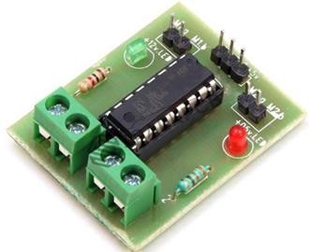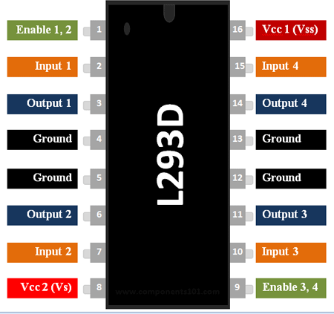

## How to use a L293D Motor Driver IC:

Using this L293D motor driver IC is very simple. The IC works on the principle of Half H-Bridge, let us not go too deep into what H-Bridge means, but for now just know that H bridge is a set up which is used to run motors both in clock wise and anti clockwise direction. As said earlier this IC is capable of running two motors at the any direction at the same time, the circuit to achieve the same is shown below.

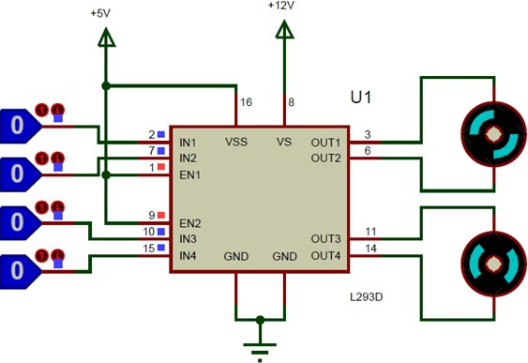

All the Ground pins should be grounded. There are two power pins for this IC, one is the Vss(Vcc1) which provides the voltage for the IC to work, this must be connected to +5V. The other is Vs(Vcc2) which provides voltage for the motors to run, based on the specification of your motor you can connect this pin to anywhere between 4.5V to 36V, here I have connected to +12V.

The Enable pins (Enable 1,2 and Enable 3,4) are used to Enable Input pins for Motor 1 and Motor 2 respectively. Since in most cases we will be using both the motors both the pins are held high by default by connecting to +5V supply. The input pins Input 1,2 are used to control the motor 1 and Input pins 3,4 are used to control the Motor 2. The input pins are connected to the any Digital circuit or microcontroller to control the speed and direction of the

motor. You can toggle the input pins based on the following table to control your motor.

|  |  |  |
| --- | --- | --- |
| Input 1 = HIGH(5v) | Output 1 = HIGH | Motor 1 rotates in Clock wise Direction |
| Input 2 = LOW(0v) | Output 2 = LOW |
| Input 3 = HIGH(5v) | Output 1 = HIGH | Motor 2 rotates in Clock wise Direction |
| Input 4 = LOW(0v) | Output 2 = LOW |

## Applications:

* Used to drive high current Motors using Digital Circuits
* Can be used to drive Stepper motors
* High current LED’s can be driven
* Relay Driver module (Latching Relay is possible)
  1. **IR Sensor:**

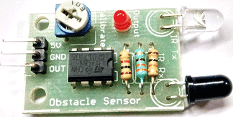

# Pin Configuration:

|  |  |
| --- | --- |
| **Pin Name** | **Description** |
| VCC | Power Supply Input |
| GND | Power Supply Ground |
| OUT | Active High Output |

**IR Sensor Module Features:**

* 5VDC Operating voltage
* I/O pins are 5V and 3.3V compliant
* Range: Up to 20cm
* Adjustable Sensing range
* Built-in Ambient Light Sensor
* 20mA supply current
* Mounting hole

# Brief about IR Sensor Module:

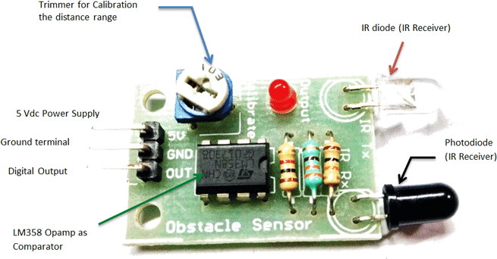

The IR sensor module consists mainly of the IR Transmitter and Receiver, Opamp, Variable Resistor (Trimmer pot), output LED in brief.

**IR LED Transmitter:**

[IR LED](https://components101.com/ir-led-pinout-datasheet) emits light, in the range of Infrared frequency. IR light is invisible to us as its wavelength (700nm – 1mm) is much higher than the visible light range. IR LEDs have light emitting angle of approx. 20-60 degree and range of approx. few centimeters to several feets, it depends upon the type of IR transmitter and the manufacturer. Some transmitters have the range in kilometers. IR LED white or transparent in colour, so it can give out amount of maximum light.

**Photodiode Receiver:**

Photodiode acts as the IR receiver as its conducts when light falls on it. Photodiode is a semiconductor which has a P-N junction, operated in Reverse Bias, means it start conducting the current in reverse direction when Light falls on it, and the amount of current flow is proportional to the amount of Light. This property makes it useful for IR detection. Photodiode looks like a LED, with a black colour coating on its outer side, Black colour absorbs the highest amount of light.

**LM358 Opamp:**

[**LM358**](https://components101.com/ic-lm358-pinout-details-datasheet) is an Operational Amplifier (Op-Amp) is used as voltage comparator in the IR sensor. the comparator will compare the threshold voltage set using the preset (pin2) and the photodiode’s series resistor voltage (pin3).

Photodiode’s series resistor voltage drop > Threshold voltage = Opamp output is High

Photodiode’s series resistor voltage drop < Threshold voltage = Opamp output is Low

When Opamp's output is **high** the LED at the Opamp output terminal **turns ON** (Indicating the detection of Object).

**Variable Resistor:**

The variable resistor used here is a preset. It is used to calibrate the distance range at which object should be detected.

## DC Motor or Direct Current Motor:

The electric motor operated by dc is called **dc motor**. This is a device that converts DC electrical energy into a mechanical energy.

## Principle of DC Motor:

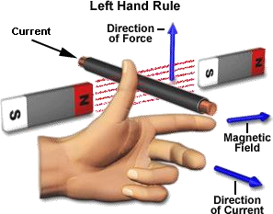When a current carrying conductor is placed in a [**magnetic field**](https://www.electrical4u.com/magnetic-field/), it experiences a torque and has a tendency to move. In other words, when a magnetic field and an electric field interact, a mechanical force is produced. The **DC motor** or **direct current motor** works on that principal. This is known as motoring action.

The direction of rotation of a this motor is given by [Fleming’s left hand rule](https://www.electrical4u.com/fleming-left-hand-rule-and-fleming-right-hand-rule/), which states that if the index finger, middle finger, and thumb of your left

hand are extended mutually perpendicular to each other and if the index finger represents the direction of magnetic field, middle finger indicates the direction of current, then the thumb represents the direction in which force is experienced by the shaft of the **DC motor**.

Structurally and construction wise a direct current motor is exactly similar to a [**DC generator**](https://www.electrical4u.com/principle-of-dc-generator/), but electrically it is just the opposite. Here we unlike a generator we supply electrical energy to the input port and derive mechanical energy from the output port. We can represent it by the block diagram shown below.

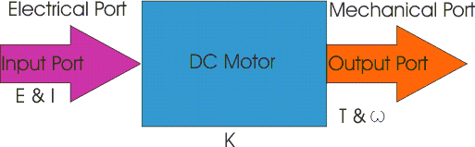

Here in a DC motor, the supply [voltage](https://www.electrical4u.com/voltage-or-electric-potential-difference/) E and [current](https://www.electrical4u.com/electric-current-and-theory-of-electricity/) I is given to the electrical port or the input port and we derive the mechanical output i.e. torque T and speed ω from the mechanical port or output port.

the parameter K relates the input and output port variables of the **direct current motor**.



So from the picture above, we can well understand that motor is just the opposite phenomena of a DC generator, and we can derive both motoring and generating operation from the same machine by simply reversing the ports.

## Detailed Description of a DC Motor:

To understand the DC motor in details lets consider the diagram below,

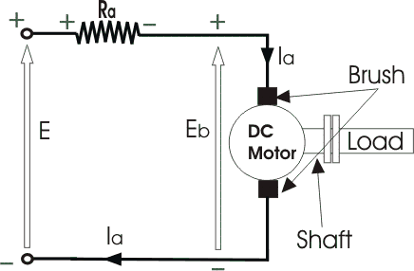

The circle in the center represents the direct current motor. On the circle, we draw the brushes. On the brushes, we connect the external terminals, through

which we give the supply voltage. On the mechanical terminal, we have a shaft coming out from the center of the armature, and the shaft couples to the mechanical load. On the supply terminals, we represent the armature resistance Ra in series.

Now, let the input voltage E, is applied across the brushes. [**Electric current**](https://www.electrical4u.com/electric-current-and-theory-of-electricity/)which flows through the rotor armature via brushes, in presence of the [**magnetic field**](https://www.electrical4u.com/magnetic-field/), produces a torque Tg. Due to this torque Tg the dc motor armature rotates. As the armature conductors are carrying currents and the armature rotates inside the stator magnetic field, it also produces an emf Eb in the manner very similar to that of a generator. The generated Emf Eb is directed opposite to the supplied voltage and is known as the back Emf, as it counters the forward voltage.

The back emf like in case of a generator is represented by

Where, P = no of poles φ = [**flux**](https://www.electrical4u.com/what-is-flux-types-of-flux/) per pole

Z= No. of conductors

A = No. of parallel paths

and N is the speed of the DC Motor.

So, from the above equation, we can see Eb is proportional to speed ‘N.’

That is whenever a direct current motor rotates; it results in the generation of back Emf. Now let’s represent the rotor speed by ω in rad/sec. So Eb is proportional to ω.

So, when the application of load reduces the speed of the motor, Eb decreases. Thus the [**voltage difference**](https://www.electrical4u.com/voltage-or-electric-potential-difference/) between supply voltage and back emf increases that means E − Eb increases. Due to this increased voltage difference, the armature current will increase and therefore torque and hence speed increases. Thus a DC Motor is capable of maintaining the same speed under variable load.

Now armature current Ia is represented by

Now at starting,speed ω = 0 so at starting Eb = 0.

Now since the [**armature winding**](https://www.electrical4u.com/armature-winding-pole-pitch-coil-span-commutator-pitch/)[**electrical resistance**](https://www.electrical4u.com/electrical-resistance-and-laws-of-resistance/) Ra is small, this motor has a very high starting current in the absence of back Emf. As a result we need to use a starter for starting a DC Motor.

Now as the motor continues to rotate, the back emf starts being generated and gradually the [**current**](https://www.electrical4u.com/electric-current-and-theory-of-electricity/) decreases as the motor picks up speed.

## Types of DC Motors:

**Direct motors** are named according to the connection o the field winding with the armature. There are 3 types:

## [Shunt wound DC motor](https://www.electrical4u.com/shunt-wound-dc-motor-dc-shunt-motor/)

1. [**Series wound DC motor**](https://www.electrical4u.com/series-wound-dc-motor-or-dc-series-motor/)

## [Compound wound DC motor](https://www.electrical4u.com/compound-wound-dc-motor-or-dc-compound-motor/)

**CHAPTER 3: CIRCUIT DIAGRAM:**

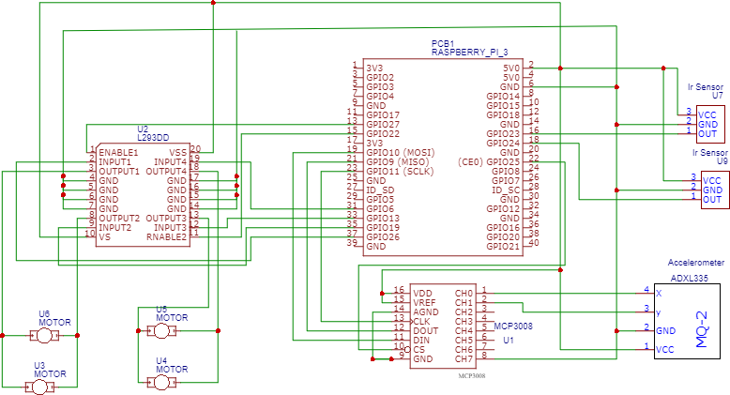

## CHAPTER 4: PROGRAMMING

* 1. **Introduction to Python:**

Python is a widely used general-purpose, high level programming language. It was initially designed by Guido van Rossum in 1991 and developed by Python Software

Foundation. It was mainly developed for emphasis on code readability, and its syntax allows programmers to express concepts in fewer lines of code.

Python is a programming language that lets you work quickly and integrate systems more efficiently.

It is used for:

* + - web development (server-side),
    - software development,
    - mathematics,
    - System scripting.

## What can Python do?

* + - Python can be used on a server to create web applications.
    - Python can be used alongside software to create workflows.
    - Python can connect to database systems. It can also read and modify files.
    - Python can be used to handle big data and perform complex mathematics.
    - Python can be used for rapid prototyping, or for production-ready software development.

## Why Python?

* + - Python works on different platforms (Windows, Mac, Linux, Raspberry Pi, etc).
    - Python has a simple syntax similar to the English language.
    - Python has syntax that allows developers to write programs with fewer lines than some other programming languages.
    - Python runs on an interpreter system, meaning that code can be executed as soon as it is written. This means that prototyping can be very quick.
    - Python can be treated in a procedural way, an object-orientated way or a functional way.

## Good to know:

* + - The most recent major version of Python is Python 3, which we shall be using in this tutorial. However, Python 2, although not being updated with anything other than security updates, is still quite popular.
    - Python 2.0 was released in 2000, and the 2.x versions were the prevalent releases until December 2008. At that time, the development team made the decision to release version 3.0, which contained a few relatively small but significant changes that were not backward compatible with the 2.x versions. Python 2 and 3 are very similar, and some features of Python 3 have been backported to Python 2. But in general, they remain not quite compatible.
    - Both Python 2 and 3 have continued to be maintained and developed, with periodic release updates for both. As of this writing, the most recent versions available are 2.7.15 and 3.6.5. However, an official [End](https://pythonclock.org/) [Of Life date of January 1, 2020](https://pythonclock.org/) has been established for Python 2, after which time it will no longer be maintained.
    - Python is still maintained by a core development team at the Institute, and Guido is still in charge, having been given the title of BDFL (Benevolent Dictator For Life) by the Python community. The name Python, by the way, derives not from the snake, but from the British

comedy troupe [Monty Python’s Flying Circus](https://en.wikipedia.org/wiki/Monty_Python%27s_Flying_Circus), of which Guido was, and presumably still is, a fan. It is common to find references to Monty Python sketches and movies scattered throughout the Python documentation.

* + - It is possible to write Python in an Integrated Development Environment, such as Thonny, Pycharm, Netbeans or Eclipse which are particularly useful when managing larger collections of Python files.

## Python Syntax compared to other programming languages:

* + - Python was designed to for readability, and has some similarities to the English language with influence from mathematics.
    - Python uses new lines to complete a command, as opposed to other programming languages which often use semicolons or parentheses.
    - Python relies on indentation, using whitespace, to define scope; such as the scope of loops, functions and classes. Other programming languages often use curly-brackets for this purpose.

## Python is Interpreted:

* + - Many languages are compiled, meaning the source code you create needs to be translated into machine code, the language of your

computer’s processor, before it can be run. Programs written in an interpreted language are passed straight to an interpreter that runs them directly.

* + - This makes for a quicker development cycle because you just type in your code and run it, without the intermediate compilation step.
    - One potential downside to interpreted languages is execution speed.

Programs that are compiled into the native language of the computer processor tend to run more quickly than interpreted programs. For some applications that are particularly computationally intensive, like graphics processing or intense number crunching, this can be limiting.

* + - In practice, however, for most programs, the difference in execution speed is measured in milliseconds, or seconds at most, and not appreciably noticeable to a human user. The expediency of coding in an interpreted language is typically worth it for most applications.
    - For all its syntactical simplicity, Python supports most constructs that would be expected in a very high-level language, including complex dynamic data types, structured and functional programming, and [object-oriented programming](https://realpython.com/python3-object-oriented-programming/).
    - Additionally, a very extensive library of classes and functions is available that provides capability well beyond what is built into the language, such as database manipulation or GUI programming.
    - Python accomplishes what many programming languages don’t: the language itself is simply designed, but it is very versatile in terms of what you can accomplish with it.

## Introduction to Firebase:

**A brief post about what Firebase is all about, and it’s new NoSQL Database — Cloud Firestore**



With a variety of server-side technologies that are on the market today, developers have a tough job of deciding what kind of backend is most suitable for their app.

In this post, we will explore one of these choices that go by the name of Firebase , and all the tools and services that it provides.

## [Firebase](http://firebase.google.com/official/site‎):

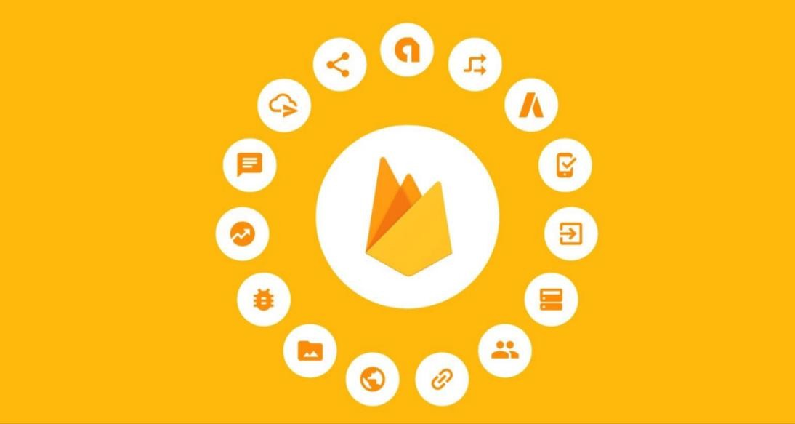

Firebase is a mobile and web app development platform that provides developers with a plethora of tools and services to help them develop high- quality apps, grow their user base, and earn more profit.

## A Brief History:

Back in 2011, before Firebase was Firebase, it was a startup called Envolve. As Envolve, it provided developers with an API that enabled the integration of online chat functionality into their website.

What’s interesting is that people used Envolve to pass application data that was more than just chat messages. Developers were using Envolve to sync application data such as a game state in real time across their users.

This led the founders of Envolve, [**James Tamplin**](https://twitter.com/JamesTamplin) and [**Andrew Lee**](https://twitter.com/startupandrew), to separate the chat system and the real-time architecture. In April 2012, Firebase was created as a separate company that provided Backend-as-a- Service with *real-time functionality.*

After it was acquired by Google in 2014, Firebase rapidly evolved into the multifunctional behemoth of a mobile and web platform that it is today.

## Firebase Services:

Firebase Services can be divided into two groups:

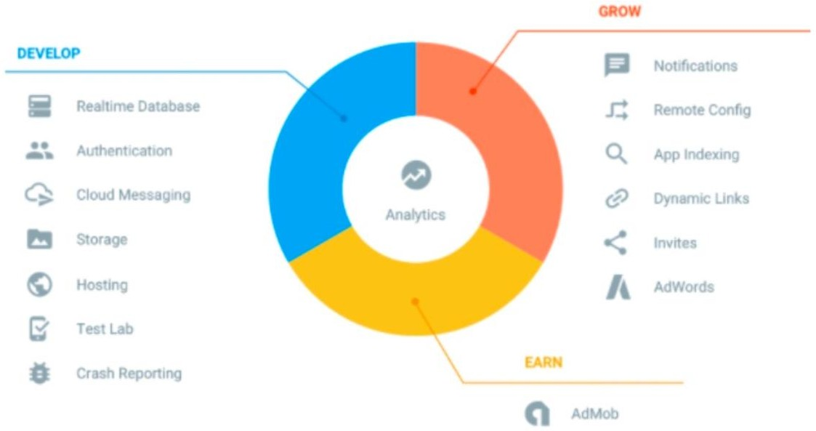

## Develop & test your app:

* + - [Realtime Database](https://firebase.google.com/docs/database/)
    - [Auth](https://firebase.google.com/docs/auth/)
    - [Test Lab](https://firebase.google.com/docs/test-lab/)
    - [Crashlytics](https://firebase.google.com/docs/crashlytics/)
    - [Cloud Functions](https://firebase.google.com/docs/functions/)
    - [Firestore](https://firebase.google.com/docs/firestore/)
    - [Cloud Storage](https://firebase.google.com/docs/storage/)
    - [Performance Monitoring](https://firebase.google.com/docs/perf-mon/)
    - [Crash Reporting](https://firebase.google.com/docs/crash/)
    - [Hosting](https://firebase.google.com/docs/hosting/)

## Grow & Engage your audience:

* + - [Firebase Analytics](https://firebase.google.com/docs/analytics/)
    - [Invites](https://firebase.google.com/docs/invites/)
    - [Cloud Messaging](https://firebase.google.com/docs/cloud-messaging/)
    - [Predictions](https://firebase.google.com/docs/predictions/)
    - [AdMob](https://firebase.google.com/docs/admob/)
    - [Dynamic Links](https://firebase.google.com/docs/dynamic-links/)
    - [Adwords](https://firebase.google.com/docs/adwords/)
    - [Remote Config](https://firebase.google.com/docs/remote-config/)
    - [App Indexing](https://firebase.google.com/docs/app-indexing/)

## Realtime Database:

The Firebase Realtime Database is a cloud-hosted NoSQL database that lets you store and sync between your users in realtime.

The Realtime Database is really just one big JSON object that the developers can manage in realtime.

Realtime Database => A Tree of Values

With just a single API, the Firebase database provides your app with both the current value of the data and any updates to that data.

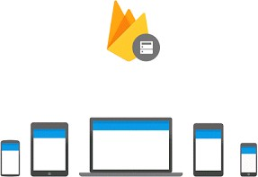

Realtime syncing makes it easy for your users to access their data from any device, be it web or mobile. Realtime Database also helps your users collaborate with one another.

Another amazing benefit of Realtime Database is that it ships with mobile and web SDKs, allowing you to build your apps without the need for servers.

When your users go offline, the Realtime Database SDKs use local cache on the device to serve and store changes. When the device comes online, the local data is automatically synchronized.

The Realtime Database can also integrate with Firebase Authentication to provide a simple and intuitive authentication process.

## Authentication:

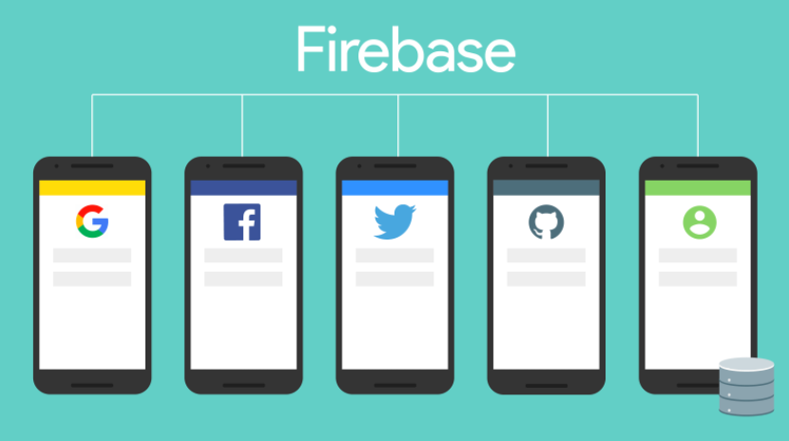

Firebase Authentication provides backend services, easy-to-use SDKs, and ready-made UI libraries to authenticate users to your app.

Normally, it would take you months to set up your own authentication system. And even after that, you would need to keep a dedicated team to maintain that system. But if you use Firebase, you can set up the entire system in under 10 lines of code that will handle everything for you, including complex operations like account merging.

You can authenticate your app’s users through the following methods:

* + - Email & Password
    - Phone numbers
    - Google
    - Facebook
    - Twitter
    - & more!

Using Firebase Authentication makes building secure authentication systems easier, while also improving the sign-in and onboarding experience for end users.

Firebase Authentication is built by the same people who created Google Sign-in, Smart Lock, and Chrome Password Manager.

## Firebase Cloud Messaging (FCM):

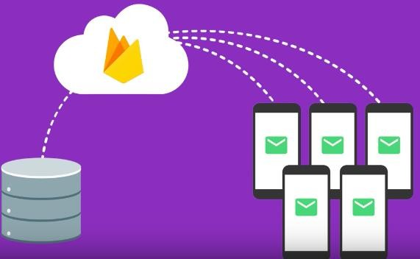

Firebase Cloud Messaging (FCM) provides a reliable and battery-efficient connection between your server and devices that allows you to deliver and receive messages and notifications on iOS, Android, and the web at no cost.

You can send notification messages (2KB limit) and data messages (4KB limit).

Using FCM, you can easily target messages using predefined segments or create your own, using demographics and behavior. You can send messages to a group of devices that are subscribed to specific topics, or you can get as granular as a single device.

FCM can deliver messages instantly, or at a future time in the user’s local time zone. You can send custom app data like setting priorities, sounds, and expiration dates, and also track custom conversion events.

The best thing about FCM is that there is hardly any coding involved! FCM is completely integrated with Firebase Analytics, giving you detailed engagement and conversion tracking.

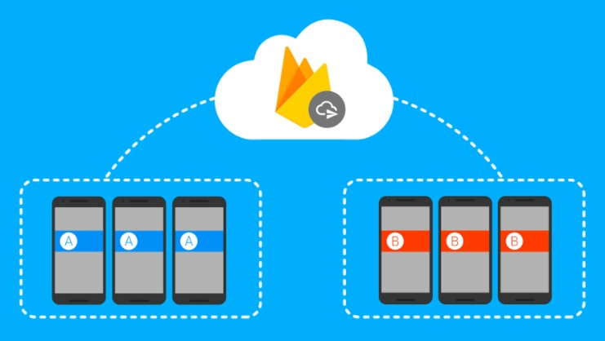

You can also use A/B testing to try out different versions of your notification messages, and then select the one which performs best against your goals.

## Firebase Database Query:

Firebase has simplified the process of retrieving specific data from the database through queries. Queries are created by chaining together one or more filter methods.

Firebase has 4 ordering functions:

* Order By Key()
* Order By Child(‘child’)
* Order By Value()
* Order By Priority()

Note that you will only receive data from a query if you have used the on() or once() method.

You can also use these advanced querying functions to further restrict data:

* Start At(‘value’)
* End At(‘value’)
* Equal To(‘child\_key’)
* Limit To First(10)
* Limit To Last(10)

In SQL, the basics of querying involve two steps. First, you select the columns from your table. Here I am selecting the Users column. Next, you can apply a restriction to your query using the WHERE clause. From the below-given query, I will get a list of Users whose name is GeekyAnts.

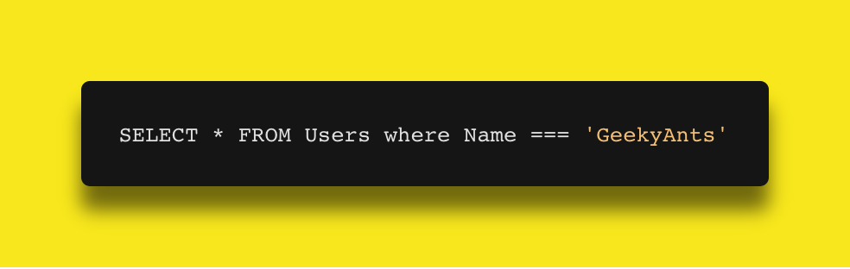

You can also use the LIMIT clause, which will restrict the number of results that you will get back from your query.

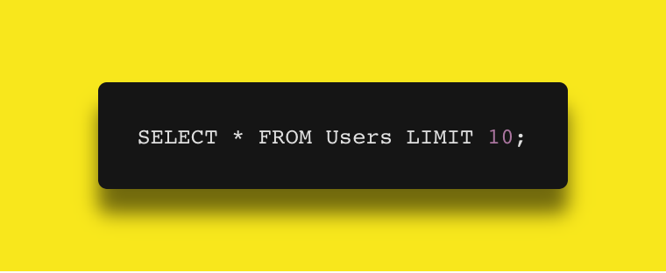

In Firebase, querying also involves two steps. First, you create a reference to the parent key and then you use an ordering function. Optionally, you can also append a querying function for a more advanced restricting.

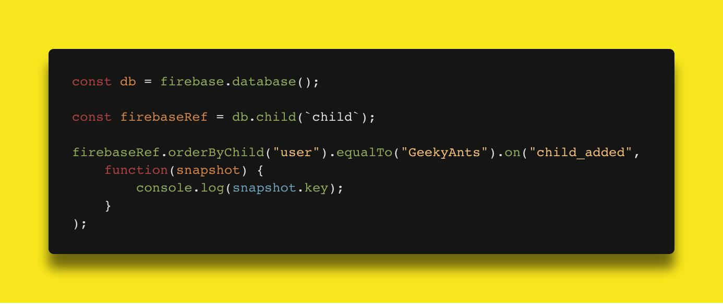

## How to Store Data? => Firebase Storage

Firebase Storage is a standalone solution for uploading user-generated content like images and videos from an iOS and Android device, as well as the Web.

Firebase Storage is designed specifically to **scale your apps, provide security,** and **ensure network resiliency.**

Firebase Storage uses a simple folder/file system to structure its data.

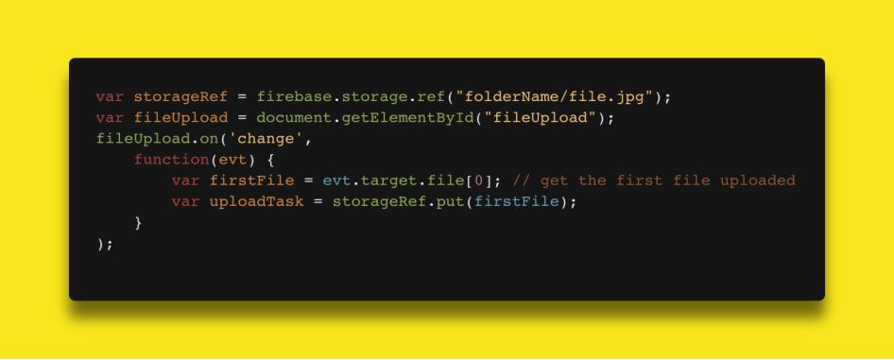

## Firebase Test Labs:

Firebase Test Labs provides a large number of mobile test devices to help you test your apps.

Firebase Test Labs comes with 3 modes of testing:

## Instrumentation Test:

These are tests that you written specifically to test your app, using frameworks like Espresso and UI Automaton 2.0

* Robo Test

This test is for people who just want to relax and let Firebase worry about tests. Firebase Test Labs can simulate user touch and see how each component of the app functions.

* Game Loop Test

Test Labs support game app testing. It comes with a beta support for using a “demo mode” where the game app runs while simulating the actions of the player.

## Remote Config:

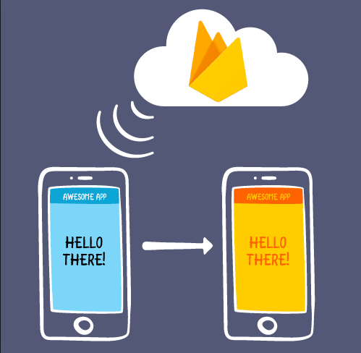

Remote config essentially allows us to publish updates to our users immediately. Whether we wish to change the color scheme for a screen, the layout for a particular section in our app or show promotional/seasonal options — this is completely doable using the server side parameters without the need to publish a new version.

Remote Config gives us the power to:

* Quickly and easily update our applications without the need to publish a new build to the app/play store.
* Effortlessly set how a segment behaves or looks in our application based on the user/device that is using it.

## Firebase App Indexing:

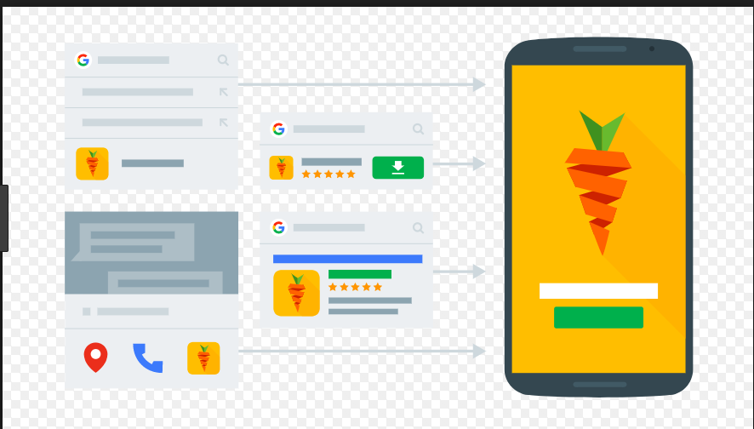

To get your app’s content indexed by Google, use the same URLs in your app that you use on your website and verify that you own both your app and your website. Google Search crawls the links on your website and serves them in Search results. Then, users who’ve installed your app on their devices go directly to the content in your app when they click on a link.

## Firebase Dynamic Links:

Deep links are URLs that take you to a content. Most web links are deep links.

Firebase can now modify deep links into Dynamic Links! Dynamic Links allow the user to directly come to a particular location in your app.

There are 3 fundamental uses for Dynamic Links

* + - Convert Mobile Web Users to Native App Users.

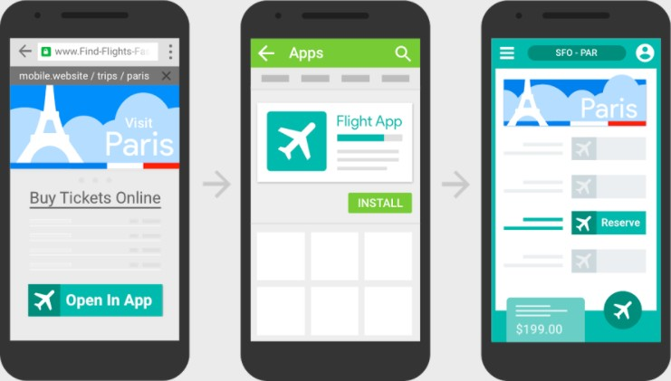

* + - Increase conversion for user-to-user sharing. By converting your app’s users, when the app is shared with other users you can skip the generic message which is shown when a user downloads it from the store. Instead, you can show them personalised greeting message.

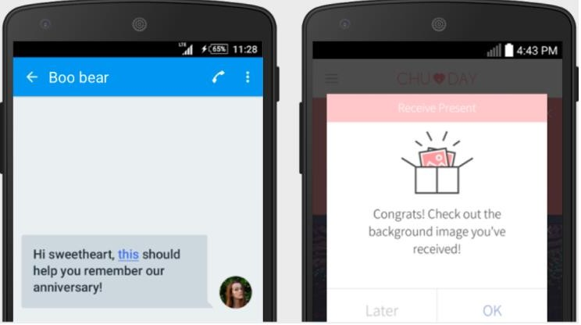

* + - Drive installs from the third party. You can use social media networks, email, and SMS can be used to increase your target audience. When users install the app, they can see the exact content of your campaigns.

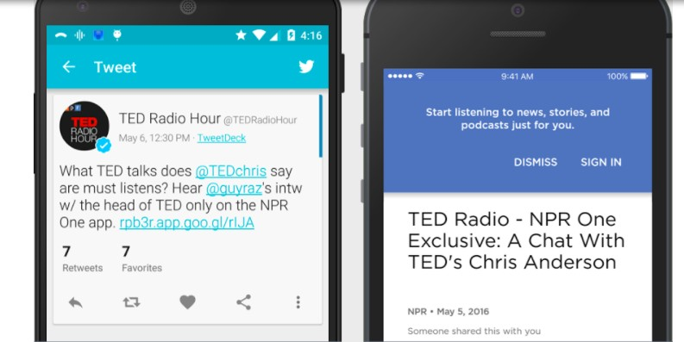

## Firestore:

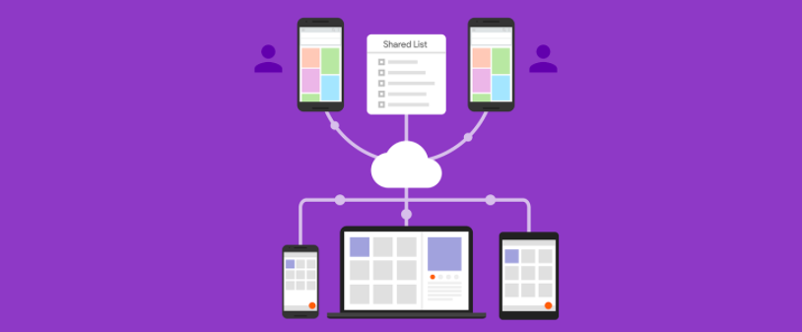

Cloud Firestore is a NoSQL document database that lets you easily store, sync, and query data for your mobile and web apps — at a global scale.

Though this may sound like something similar to the Realtime Database, Firestore brings many new things to the platform that makes it into something completely different from Realtime Database.

## Improved Querying and Data Structure:

Where Realtime Database stores data in the form of a giant JSON tree, Cloud Firestore takes a much more structured approach. Firestore keeps its data inside objects called documents. These documents consist of key-value pairs and can contain any kind of data, from strings to binary data to even objects that resemble JSON trees (Firestore calls it as maps). The documents, in turn, are grouped into collections.

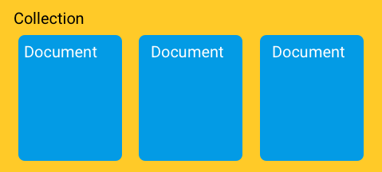

Firestore database can consist of multiple collections that can contain documents pointing towards sub-collections. These sub-collections can again contain documents that point to other sub-collections, and so on.

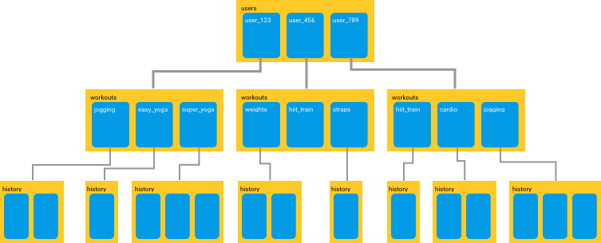

You can build hierarchies to store related data and easily retrieve any data that you need using queries. All queries can scale with the size of your result set, so your app is ready to scale from its first day itself.

Firestore’s queries are *shallow.* By this, I mean to say that in Firestore, you can simply fetch any document that you want without having to fetch all of the data that is contained in any of its linked sub-collections.

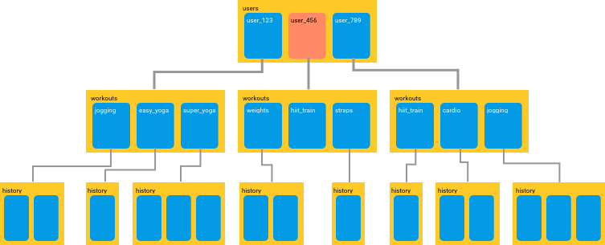

You can fetch a single document without having to grab any of its sub- collections

## Query with Firestore:

Imagine that you have created a collection in Firestore that contains a list of Cities. So, before you can send out a query, you will have to store the database inside a variable.

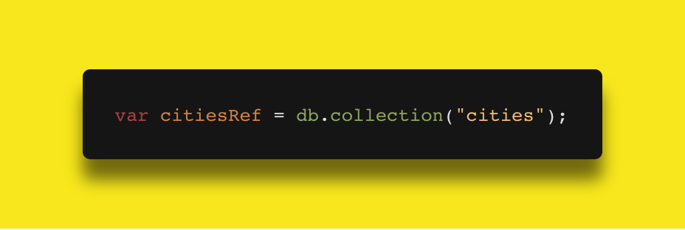

Here, citiesRef is that variable that contains your collection of cities. Now, if you want to find a list of capital cities, you would write a query like this:

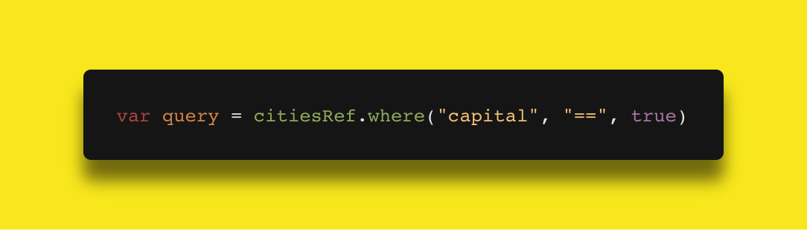

Here’s another example of queries in Firestore. Say you want to see only 2 of cities from your database whose population is more than 100,000.

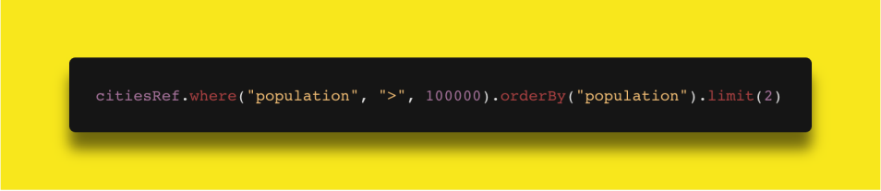

But Cloud Firestore can make querying even easier! In some cases, Cloud Firestore can automatically search your database across multiple fields.

Firestore will guide you towards automatically building an index that will help Firestore to make querying extremely simple.

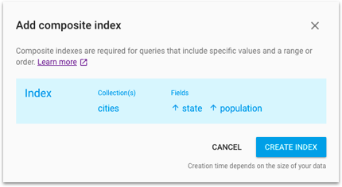

## Better Scalability:

Though Firebase’s Realtime Database is capable of scaling, things will start to get crazy when you app becomes really popular or if your database becomes really massive.

Cloud Firestore is based on Googles Cloud infrastructure. This allows it to scale much more easily and to a greater capacity than the Realtime Database.

## Multi-Region Database:

In Firestore, your data is automatically copied to various regions. So if one data center goes offline due to some unforeseen reason, you can be sure that your app’s data is still safe somewhere else.

Firestore’s multi-region database also provides strong consistency. Any changes to your data will be mirrored across every copy of your database.

## Different Pricing Model:

The Realtime Database charges its users based on the amount of data that you have stored in the database.

Cloud Firestore also charges you for the same, but the cost is significantly lower than that of Realtime Database and instead of basing the cost on the amount of data stored, Firestore’s pricing is driven by the number of reads/writes that you perform.

Check out this blog post to know more about Cloud Firestore:

## [Cloud Firestore for Realtime Database Developers](https://firebase.googleblog.com/2017/10/cloud-firestore-for-rtdb-developers.html)

[Hey, did you hear the big news? We just announced the beta release of](https://firebase.googleblog.com/2017/10/cloud-firestore-for-rtdb-developers.html) [Cloud Firestore -- the new database that lets you…firebase.googleblog.com](https://firebase.googleblog.com/2017/10/cloud-firestore-for-rtdb-developers.html)

You can also go through this codelab to better understand how Cloud Firestore works:

## [Cloud Firestore Web Codelab](https://codelabs.developers.google.com/codelabs/firestore-web/index.html?index=..%2F..%2Fgdd17&_blank)

We're almost there--before we can write documents to Firestore we need to open up Firestore's security rules and…codelabs.developers.google.com

## Latest Updates in Firebase:

[**Robo Scripts**](https://firebase.googleblog.com/2017/12/firebase-test-lab-december-2017-update.html)**:**

Firebase Test Labs have this amazing service called **Robo Test** that allows us to test our app with having to write any test scripts. With Robo Test, you

can have Firebase test your app completely, even fill in specific form fields and push buttons!

Now Firebase has come up with another cool testing feature called **Robo Scripts.** With Robo Scripts, you can record a series of actions for Firebase to take in you app.

When you run a Robo Test with a Robo Script attached to it, Firebase first steps through the your recorded actions from the Robo Script and then explores the app as usual.

## [Firebase Predictions](https://firebase.google.com/docs/predictions/):

Firebase now comes with machine learning, with it uses to analyse your app’s data and create dynamic user groups based on the user’s predicted behavior.

Firebase Predictions can work with Remote Config to increase conversions by providing a customized experience based on each of your user’s behavior.

Or, it can work with the Notifications composer to deliver the right message to the right user group.

Firebase Predictions can also work hand-in-hand with A/B testing to evaluate the effectiveness of your prediction based strategies.

I am [Rajat S](https://medium.com/%40geeky_writer_), a Technical Content Writer at [GeekyAnts](https://geekyants.com/?utm_source=medium&utm_medium=article&utm_campaign=blog). Aspiring Coder who has a long way to go. A Die-Hard DC Comics Fan who loves Marvel Movies. Follow me on [Twitter](https://twitter.com/rajatk16) and [Facebook](https://www.facebook.com/rajat.k16) to know about all the amazing things that are happening at [GeekyAnts](https://geekyants.com/?utm_source=medium&utm_medium=article&utm_campaign=blog).

Thanks to [Aditya Srivastava](https://medium.com/%40aditya.srivastav2013) and [Rahul Raj](https://medium.com/%40ra11) for helping with this post and for helping me understand everything about Firebase and Cloud Firestore. Both Aditya and Rahul are Software Developers working at [GeekyAnts](https://geekyants.com/?utm_source=medium&utm_medium=article&utm_campaign=blog).

## Android:

Android is a Linux based operating system it is designed primarily for touch screen mobile devices such as smart phones and tablet computers. The operating system has developed a lot in last 15 years starting from black and white phones to recent smart phones or mini computers. One of the most widely used mobile OS these days is android. The android is software that was founded in Palo Alto of California in 2003.

The android is a powerful operating system and it supports large number of applications in Smartphones. These applications are more comfortable and advanced for the users. The hardware that supports android software is based on ARM architecture platform. The android is an open source operating system means that it’s free and any one can use it. The android has got millions of apps available that can help you managing your life one or other way and it is available low cost in market at that reasons android is very popular.

The android development supports with the full java programming language. Even other packages that are API and JSE are not supported. The first version 1.0 of android development kit (SDK) was released in 2008 and latest updated version is jelly bean.

The android is a operating system and is a stack of software components which is divided into five sections and four main layers that is

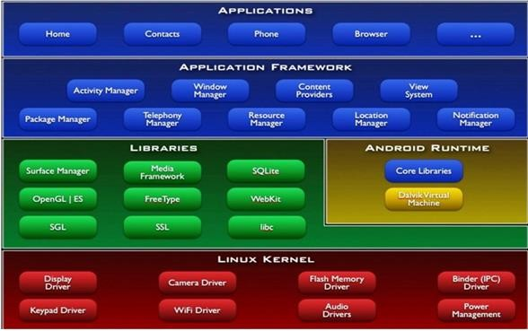

## Linux kernel:

The android uses the powerful Linux kernel and it supports wide range of hardware drivers. The kernel is the heart of the operating system that manages input and output requests from software. This provides basic system functionalities like process management, memory management, device

management like camera, keypad, display etc the kernel handles all the things. The Linux is really good at networking and it is not necessary to interface it to the peripheral hardware. The kernel itself does not interact directly with the user but rather interacts with the shell and other programs as well as with the hard ware devices on the system.

## Libraries:

The on top of a Linux kennel there is a set of libraries including open source web browser such as webkit, library libc. These libraries are used to play and record audio and video. The SQLite is a data base which is useful for storage and sharing of application data. The SSL libraries are responsible for internet security etc.

## Android Runtime:

The android runtime provides a key component called Dalvik Virtual Machine which is a kind of java virtual machine. It is specially designed and optimized for android. The Dalvik VM is the process virtual machine in the android operating system. It is software that runs apps on android devices.

The Dalvik VM makes use of Linux core features like memory management and multithreading which is in a java language. The Dalvik VM enables every android application to run it own process. The Dalvik VM executes the files in the .dex format.

## Application frame work:

The application frame work layer provides many higher level services to applications such as windows manager, view system, package manager, resource manager etc. The application developers are allowed to make use of these services in their application.

## Applications:

You will find all [the android applications](https://www.edgefxkits.com/home-automation-by-android-application-based-remote-control?utm_source=elprocus.com) at the top layer and you will write your application and install on this layer. Examples of such applications are contacts, books, browsers, services etc. Each application perform a different role in the overall applications.

## Advantages:

* + - Android is Linux based open source operating system , it can be developed by any one
    - Easy access to the android apps
    - You can replace the battery and mass storage, disk drive and UDB option
    - Its supports all Google services
    - The operating system is able to inform you of a new SMS and Emails or latest updates.
    - It supports Multitasking
    - Android phone can also function as a router to share internet
    - Its free to customize
    - Can install a modified ROM
    - Its supports 2D and 3D graphics

## LITERATURE SURVEY

**Project Title :** Smart Clothing Design Issues in Military Applications

**Author Name :** Sofia Scataglini1

## Year of Publish 2017

**Abstract :** Smart clothes development history started in the military field and this still remains a main application field. A soldier is like a high-performance athlete, where monitoring of physical and physiological capabilities of primary importance. Wearable systems and smart clothes can answer this need appropriately. Smart cloth represents a “second skin” that has a close, “intimate” relation with the human body. The relation is physiological, psychological, biomechanical and ergonomical. Effectiveness of functional wear is based on the integration of all these considerations into the design of a smart clothing system. The design of smart cloth is crucial to obtain the best results. Identifying all the steps involved in the co-design workflow can prevent a decrease in wearer’s performance ensuring a more successful design. This paper presents all the steps involved in the workflow for the design of a proposed solution of a smartgarment for monitoring soldier’s performance.

**Project Title :** Smart Clothes for Security Personnel

**Author Name :** M.Vigneshwaran

## Year of Publish 2017

**Abstract :** In national security, details matter butwaiting to get them right would lead to failure. Developing a centralised system to monitor the groups of security personnel would help in making vital decisions on time. Hence using IOT technology, we create a smart cloth which transmits live location and psycho-physiological data of security forces to a permissioned database where the data is analysed to understand the state of troops. These sensitive data are protected from tampering using block-chain.

**Project Title :** New generation IoT-based healthcare applications: Requirements and recommendations

**Author Name :** Dragorad A.

## Year of Publish 2018

**Abstract :** Internet of Things (IoT) and healthcare are two valuable application requirements in the emerging 5G mobile networks. In a broad sense m-health represents the delivery of healthcare services through mobile devices, the function of which is to capture, analyze, store and transmit health information from multiple sources, including sensors and other biomedical acquisition systems. Solutions based on e/m-health decrease medical errors improving at the same time the efficiency health services and reducing operating costs. This paper surveys IoT for healthcare together with services and applications, security and technologies for promoting the corresponding services. In addition, this paper is going to invoke 5G network technology and health IoT including Internet of medical things. Next, current standardization activities and recommendations are outlined. Proposals for the future work conclude the presentation.

**Project Title :** Technological Solutions for Health Care Protection

and Services Through Internet Of Things(IoT)

**Author Name :** E. Laxmi Lydia

## Year of Publish 2020

**Abstract :** Internet of things (IoT) creates a path to blocks that progress privately providing security. The IoT leads to software fields, together with well being care. The IoT innovation is upgrade brand with Health care with reassuring high-tech, industrial, and social potential. This paper manifest advances in IoT founded well being care Industrial science and analysis the trendy community architecture/Systems, functions, and industrial tendencies in IoT- founded wellbeing care options. Furthermore, Extra, this paper proposes a discriminating collective safety model to slash protection risk; discuses how exceptional contraption similar to tremendous knowledge,

ambient intelligence, and wearable’s will also be advantage in a health care circumstances; different IoT and e-Health insurance policies and rules to determine the aid of economies and societies in terms of continuous growth in the world; and gives future research step on this collection of data regarding disorders and threats.

**Project Title :** A Health-IoT Platform Based on the Integration of Intelligent Packaging, Unobtrusive Bio-Sensor and Intelligent Medicine Box

**Author Name :** D.Ilakiya

## Year of Publish 2019

**Abstract :** A desirable system should be capable of taking care of the patients from all aspects, covering personalized medication, vital signs monitoring, on-site diagnosis and interaction with remote physicians. The project gives an experimental idea of patients health condition. the platform involves 1) an open-platform-based intelligent medicine box (iMedBox) with enhanced connectivity and interchange ability for the integration of devices and services, 2) intelligent pharmaceutical packaging (iMedPack) with communication capability enabled actuation capability enabled by functional materials, and 3) flexible and wearable bio-medical sensor device (Bio-Patch) enabled by the state-of-the-art inkjet printing technology and system-on-chip. The proposed platform seamlessly fuses IoT devices.

**Project Title :** A Health-IoT Platform based on the Biosensor and Intelligent Medicine Box

**Author Name :** Priti Bedmuttha,

## Year of Publish 2020

**Abstract :** IOT based healthcare services have a major potential for automation, let alone the drastic changes that it would bring in the field of healthcare and medicine. With time our life is integrated so much with mobile

technologies that we rely on it on multiple occasions. Health care is a major concern for elderly and blind since intake of proper medicine at prescribed time is a challenge and providing services via technologies is a sigh of relief. In this paper, an intelligent health-iot is proposed and implemented, beneficial for blinds as well because of its ability to dispense medicine. It includes an intelligent medicine box (imedbox) comprising of a medicine dispenser with enhanced connectivity, a heartbeat sensor and an android app.

**Project Title :** Internet of things (IoT) based health monitoring

system and challenges

**Author Name :** M. Sathya

## Year of Publish 2020

**Abstract :** Among the applications that Internet of Things (IoT) facilitated to the world, Healthcare applications are most important. In general, IoT has been widely used to interconnect the advanced medical resources and to offer smart and effective healthcare services to the people. The advanced sensors can be either worn or be embedded into the body of the patients, so as to continously monitor their health. The information collected in such manner, can be analzed, aggregated and mined to do the early prediction of diseases. The processing algorithms assist the physicians for the personalization of treatment and it helps to make the health care economical, at the same time, with improved outcomes. Also, in this paper, we highlight the challenges in the implementation of IoT health monitoring system in real world.

**Project Title :** An Overview on the Internet of Things

for Health Monitoring Systems

**Author Name :** Mobyen Uddin Ahmed(B),

## Year of Publish 2019

**Abstract :**The aging population and the increasing healthcare cost in hospitals are spurring the advent of remote health monitoring systems. Advances in physiological sensing devices and the emergence of reliable low- power wireless network technologies have enabled the design of remote health monitoring systems. The next generation Internet, commonly referred to as Internet of Things (IoT), depicts a world populated by devices that are able to sense, process and react via the Internet. Thus, we envision health monitoring systems that support Internet connection and use this connectivity to enable better and more reliable services. This paper presents an overview on existing health monitoring systems, considering the IoT vision. We focus on recent trends and the development of health monitoring systems in terms of: (1) health parameters and frameworks, (2) wireless communication, and

(3) security issues. We also identify the main limitations, requirements and advantages within these systems.

**Project Title :** A Study of Internet Of Things Enabled Healthcare Acceptance in Malaysia

**Author Name :** YAP SY YUAN1**,**

## Year of Publish 2019

**Abstract :** The power of Internet of Things (IoT) has disrupted the traditional business models of industries, especially in healthcare industry. The emerging of connected sensors and devices, and the advancement of wireless technology, cloud computing, and data analytics, have been transforming the healthcare from case-based paid service to value-based care service. These value-based care services is known as IoT enabled healthcare applications. The aim of the IoT enabled healthcare is to eventually provide a low-cost, advanced technology, and high accessibility care services for patients and consumers. Some developed countries have been implementing

the IoT enabled applications in healthcare sector and obtained satisfactory result. In this paper, Diffusion of Innovations (DOI) model was applied to study the IoT diffusion in public and Technology Acceptance Model (TAM) was used to study the degree of IoT is accepted in public. In addition, survey questionnaire was developed to collect data from the public and consequently identify the barriers for Malaysia to embrace the IoT into healthcare sector. After going through the data collection, IoT enabled healthcare application is accepted by most of the respondents. IoT healthcare application is reaching the decision stage that Malaysian need more persuasion to encourage them to make the decision of using the IoT healthcare application. Lastly, six major barriers for service provider and public to adopt IoT healthcare application were then identified in this paper.

**Project Title :** Soldier Health and Position Tracking System

using GPS and GSM Modem**.**

**Author Name :** Deepa J

## Year of Publish 2017

**Abstract :** Nowadays all nations keep its security at high priority. Wars are being fought for land, water and acquiring the position of most powerful nation. A country’s arm forces consist of three professional uniformed services: the army, the navy, and the air force. Soldiers being the backbone of any armed force usually lose their lives due to lack of medical help when in emergency, also soldiers who are involved in missions or in special operations get straggled on war fields and lose contact with the authorities. To overcome this concerns we had build this project which, using wireless body area sensor network (WBANS) such as temperature sensor, heartbeat sensor etc. will monitor the health status of the soldier whenever required. Also using GPS we can track the soldier’s exact location whenever required. Using oxygen level sensor we can also monitor the environmental condition, so authorities can provide essential aids. The communication is established between the soldiers and authorities via GSM. Any abnormalities

in the readings of wireless body area sensor network (WBASNs) is considered as a trigger for GSM to establish the connection between the soldier and base unit and send current location and health status to the receiver. By using all this equipments we had tried to implement the basic guarding system for the soldier in low cost, light weighted, portable and precise device.

**Project Title :** IoT Smart Home Using Eye Tracking and Voice Interfaces for Elderly and Special Needs People

**Author Name :** Ahmad F.

## Year of Publish : 2019

**Abstract :** Eye tracking has become increasingly important in many sectors because of its ability to facilitate day to day activities, especially for users with special needs, where tasks as simple as turning on a light require effort. To tackle similar issues, we propose a model that utilizes Video Oculography approach through Tobii technology with added voice interfaces using Azure cloud to help control home appliances. This model traces the user via reflected infrared light patterns and calculates the gaze position automatically. This method uses no wearable technology through Video Oculography with multiple cameras which deliver several advantages; it provides accurate gaze estimates, portability of the video recording system, and fully remote recordings. Eye tracking facilitates interactions to control home appliances when the user cannot or does not wish to use their hands by means of the IoT and cloud Technologies. Eye tracking has great impact in countless fields such as neurology, cognition, communication and security of different categories. Focus groups and usability tests show that many users were satisfied with the straightforward use of the model, flexibility and reliability in interacting with the system, and accuracy in the movement of the pointer, make this model a reliable solution to simplifying some daily tasks.

**Project Title :** Design and Implementation of Smart Wheelchair for Quadriplegia patients using IOT

**Author Name :** R. C. Joshi

## Year of Publish 2018

**Abstract :** Quadriplegia is a pathological condition identified through completely or partly paralysis of the limbs and torso.Smart wheelchair is an innovation that has an intention to create a difference for the activities of the people who are restricted by movement. This paper proposed an idea to ease those patients, who cannot perform hand movements in a way that can move a wheelchair. This paper peculiarly represents the working model of a smart wheelchair using Internet of things (IoT). Three different modes are proposed which assist the patient in free movement and information transmission to the person nearby and to the cloud. To provide movement of wheelchair in desired

direction an accelerometer based hand glove is design. Patient can transmit the requirements to the nearer ones through hand gesture using RF transmission. Third mode provides the information on cloud which can be accessed by the doctor for diagnosis.

**Project Title :** A Network Security Management System

**Author Name :** Bin Liao2

## Year of Publish 2018

**Abstract :** In recent years, the emerged network worms and attacks have distributive characteristic, which can spread globally in a very short time. Security management crossing network to co-defense network-wide attacks and improve efficiency of security administration is urgently needed. This paper

proposes a hierarchical distributed network security management system (HD-NSMS), which can centrally manage security across networks. First describes the system in macrostructure and microstructure; then discusses three key problems when building HD-NSMS: device model, alert mechanism and emergency response mechanism; at last, describes the implementation of HD-NSMS. The paper is valuable for implementing NSMS in that it derives from a practical network security management system (NSMS).

**Project Title :** DEVELOPMENT OF SMART WHEELCHAIR

**Author Name :** Suraj kumar Vishwakarma

## Year of Publish : 2017

**Abstract :** Smart Wheel Chair is mechanically controlled devices designed to have self- mobility with the help of the user command. This reduces the user’s human effort and force to drive the wheels for wheelchair

.Furthermore it also provides an opportunity for visually or physically impaired persons to move from one place to another. The wheelchair is also provided with obstacle detection system which reduces the chance of collision while on the journey. Smart wheelchair has gained a lot of interests in the recent times. These devices are useful especially in transportation from one place to another. The machines can also be used in old age homes where the old age persons have difficulty in their movements. The devices serve as a boon for those who have lost their mobility. Different types of smart wheelchair have been developed in the past but the new generations of wheelchairs are being developed and used which features the use of artificial intelligence and hence leaves a little to tinker about to the user who uses the wheel chair. The project also aims to build a similar wheel chair which would have a sort of intelligence and hence helps the user on his/her movement.

**Project Title :** Developing Intelligent Wheelchairs for the Handicapped

**Author Name :** Takashi Gomi and Ann Griffith

## Year of Publish : 2020

**Abstract :** A brief survey of research in the development of autonomy in wheelchairs is presented and AAI’s R&D to build a series of intelligent autonomous wheelchairs is discussed. A standardized autonomy management system that can be installed on readily available power chairs

which have been well-engineered over the years has been developed and tested. A behavior-based approach was used to establish sufficient on-board autonomy at minimal cost and material usage, while achieving high efficiency, sufficient safety, transparency in appearance, and extendability. So far, the add-on system has been installed and tried on two common power wheelchair models. Initial results are highly encouraging.

**Project Title :** Internet of Things (IoT): A Vision, Architectural Elements, and Future Directions

**Author Name :** Jayavardhana Gubbi

## Year of Publish : 2018

**Abstract :** Ubiquitous sensing enabled by Wireless Sensor Network (WSN) technologies cuts across many areas of modern day living. This offers the ability to measure, infer and understand environmental indicators, from delicate ecologies and natural resources to urban environments. The proliferation of these devices in a communicating-actuating network creates the Internet of Things (IoT), wherein, sensors and actuators blend seamlessly with the environment around us, and the information is shared across platforms in order to develop a common operating picture (COP). Fuelled by the recent adaptation of a variety of enabling device technologies such as RFID tags and readers, near field communication (NFC) devices and embedded sensor and actuator nodes, the IoT has stepped out of its infancy and is the the next revolutionary technology in transforming the Internet into a fully integrated Future Internet. As we move from www (static pages web) to web2 (social networking web) to web3 (ubiquitous computing web), the need for data-on-demand using sophisticated intuitive queries increases significantly. This paper presents a cloud centric vision for worldwide implementation of Internet of Things. The key enabling technologies and application domains that are likely to drive IoT research in the near future are

discussed. A cloud implementation using Aneka, which is based on interaction of private and public clouds is presented. We conclude our IoT vision by expanding on the need for convergence of WSN, the Internet and distributed computing directed at technological research community.

**Project Title :** Designing the Process Design Process

**Author Name :** Arthur W. Westerberg

## Year of Publish : 2019

**Abstract :** We suggest that designing design processes is an ill- posed problem which must be tackled with great care and in an evolutionary fashion. We argue it is an important activity, however, as companies today use a small percentage of the intellectual capital they own when designing, suggesting there is room for significant improvement. We discuss who in industry and academia are currently involved with designing design processes. Based on empirical studies we and others have carried out, we have based our approach to study and support design processes on managing the information they generate and use. We are learning how to carry out studies more effectively with industrial partners, what features we need for managing information to study and improve design processes. We are even learning some general observations about the effect of different behavior of the group on its success at designing

**Project Title :** Wheelchair control through eye blinking and IoT platform

**Author Name :** Carla G´omez-Carrasquilla

## Year of Publish : 2020

**Abstract :** Decision-making considering commands coming from eye blinking, to give mobility to a wheelchair, is not a simple task, bad decisions can end up in moving a person in a wrong direction, which will give more difficulties instead of solutions. In the actual study a microcontroller with embedded software and hardware for IoT is used, this device can manage multiple sensors as inputs and multiple actuators as outputs. The raspberry Pi

3 was selected because it is single-board computer with wireless LAN and Bluetooth Low Energy (BLE) on board. The developed system discriminates an involuntary blinking from a low motion voluntary blinking and take a decision to move forward a model wheelchair. The position and given commands are sent to an IoT platform to save the wheelchair movement data. Index Terms—COTS, Eye blinking commands, IoT device, IoT platform, Rehabilitation.

**Project Title :** Design of Multipurpose Wheel Chair for Physically Challenged and Elder People

**Author Name :** Mohan Kumar R

## Year of Publish : 2017

**Abstract :** Wheel Chair is a mobility device designed for shifting patients, moving physically challenged people from one place to another with the help of attendee or by means of self propelling. The wheel chair is divided into two different types based on the power used for mobility: 1. Manually powered wheelchairs. 2. Electric powered wheelchairs. Manual powered wheelchairs are driven by manual power which are again classified into foldable and non-foldable with or with out commode design. Electrical powered wheel chairs runs with electric power however manual operation is required to operate the joystick for the movement of the chair. The redesign of manual wheel chair was considered for this project. The design of wheel chair started by means of literature review to know its evaluation from earlier to the present generation. Market study was carried out to know the present competators available in the market with cost analysis of the existing product. Ethnography study was done to observe the need, the importance of the existing product and to address the design gap in the existing product to the user need through questionnaries. The feed back was taken from different users and attendees, concept generation and design execution was done by the

implementation of design methodologies like Quality Function Deployment, Mind mapping, Product Design Specification. The final output is a wheel chair which gives multiple option to the user and attendee by providing ease of defecation, cleaning and changing of clothes. Adjustable back rest, arm rest, leg rest provides comfort for the patient while resting. The adjustable arm rest provide ease of shifting the patient from chair to the bed or to the vehicle. Facility provided for keeping plate while having food, reading and keeping water bottle. Additional to this alarm facility is provided to inform the attendee that there is a need of his / her presence to the patient. Validation of the prototype is done and usage is found satisfactory

## CONCLUSION:

A functional prototype of a system to detect slow voluntary blinking was analyzed and tested. It was possible to obtain a reliability of 100 % in the measurements of the position and movement of a simulated wheelchair. The communication between the Raspberry and the IoT was successful and the IoT ThingSpeak platform worked following all given specifications.

## REFERENCES:

1. I.-I. N. de Estad´ıstica y Censo, “Encuesta nacional sobre discapacidad 2018,” May 2019. [Online]. Available: [https://http://inec.cr/sites/default/files/documetos-bibliotecavirtual/](https://http/inec.cr/sites/default/files/documetos-bibliotecavirtual/) reenadis2018.pdf
2. S. Shinde, S. Kumar, and P. Johri, “A review: Eye tracking interface with embedded system iot,” in *2018 International Conference on Computing, Power and Communication Technologies (GUCON)*, Sep. 2018, pp. 791– 795.
3. U. Garg, K. K. Ghanshala, R. C. Joshi, and R. Chauhan, “Design and implementation of smart wheelchair for quadriplegia patients using iot,” in *2018 First International Conference on Secure Cyber Computing and Communication (ICSCCC)*, Dec 2018, pp. 106–110.
4. A. Carrasquilla-Batista, K. Quir´os-Espinoza, and C. G´omez- Carrasquilla, “An internet of things (iot) application to control a wheelchair through eeg signal processing,” in *2017 International Symposium on Wearable Robotics and Rehabilitation (WeRob)*, Nov 2017, pp. 1–1.
5. S. Khandani, “Engineering design process, education transfer plan,” 2005. [Online].Available:https://[www.dphu.org/uploads/attachements/books/books](http://www.dphu.org/uploads/attachements/books/books) 25470*.pdf*
6. M. Varela, “Raw eeg signal processing for bci control based on voluntary eye blinks,” in *2015 IEEE Thirty Fifth Central American and Panama Convention (CONCAPAN XXXV)*, Nov 2015, pp. 1–6. Authorized
7. **WHEELCHAIR CONTROL THROUGH EYE- BLINKING AND IOT**

**PLATFORM** was published in **International Journal of Scientific Research in Engineering and Management (IJSREM)** Volume 05, Issue 04, April 2021 by Jeya Gokul CS,Alagu Sriram S,Saravana Pandi P and Krishnamurthy M. Paper:[http://ijsrem.com/download/wheelchair-control-through-eye-blinking-and-](http://ijsrem.com/download/wheelchair-control-through-eye-blinking-and-iot-platform/?wpdmdl=5427&masterkey=6076e42a056fc) [iot-platform/?wpdmdl=5427&masterkey=6076e42a056fc](http://ijsrem.com/download/wheelchair-control-through-eye-blinking-and-iot-platform/?wpdmdl=5427&masterkey=6076e42a056fc)